Xerte Online Toolkits



Installation Guide

Pat Lockley, December 2009

Tom Reijnders, April 2013

Contents

Introduction 3

Installing Xerte Online Toolkits with XAMPP on a Local Machine 4

Using XAMPP 4

A local install with an existing version of XAMPP 16

Installing Xerte Online Toolkits on a Web Server or Existing XAMPP 16

What will and won’t work on local installs 23

Properties tab 23

Folder properties tab 23

Workspace Properties tab 23

Site page of management.php and Page 4 of installer 23

Authentication in Xerte Online Toolkits 31

Guest 31

Ldap 32

Db 32

Static 32

Running Xerte Online Toolkits with Authentication from Moodle 32

How this works 32

Installation/Configuration 33

After installation/configuration 33

Bugs/feedback 33

Frequently Asked Questions 35

Site Management 37

Using Management.php 37

The Main Panel: Site 37

Controlling What Templates Are Available: Central templates 40

Manager User Accounts: Users 42

Managing User Projects: Users templates 44

Tracing Site Activity: Errors 46

Setting New Security Options: Play Security 47

RSS Options: Licenses 49

RSS Options: Feeds 50

Introduction  
Xerte Online Toolkits is a suite of tools for the creation of elearning materials. It is intended for installation on an organisation’s web server, where the full functionality can be used.

It is possible to install Xerte Online Toolkits on a standalone PC or laptop (on any operating system that supports PHP and MySQL), using third party software to provide the functionality normally provided by a web server (XAMPP). It is also possible to run Xerte Online Toolkits from a memory stick.

Installing Xerte Online Toolkits with XAMPP on a Local Machine

## Using XAMPP

This is the simplest way to get the software up and turning on a standalone machine. You will need to download and install XAMPP, download and install Xerte Online Toolkits, and then run the setup utility provided.

First, visit http://www.apachefriends.org

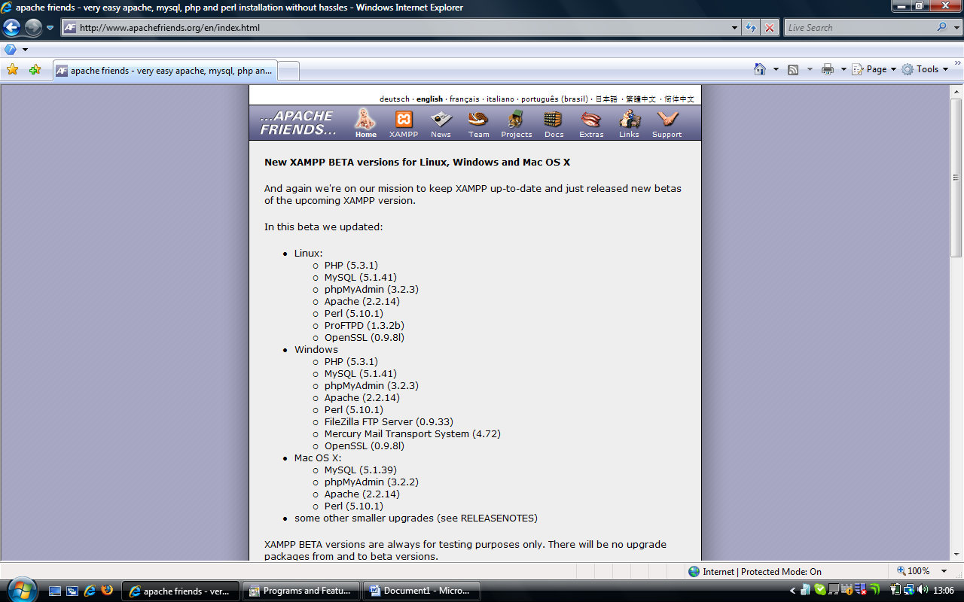

Click on the XAMPP icon on the top bar, and the XAMPP version will load. This guidance now assumes you are installing Windows XAMPP.

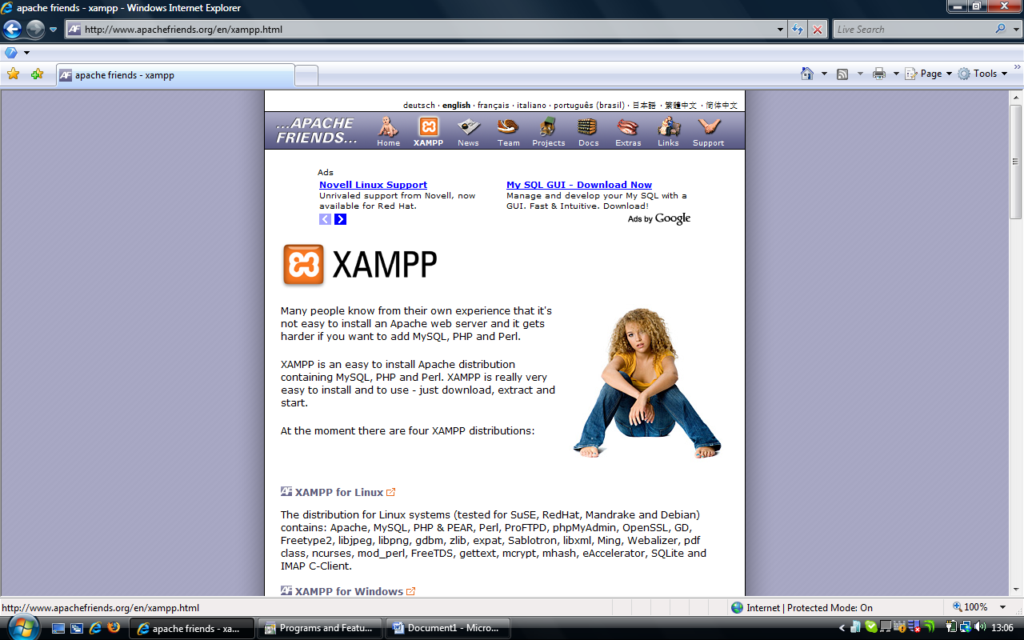

Scroll Down this page until you find the version you would like to download.

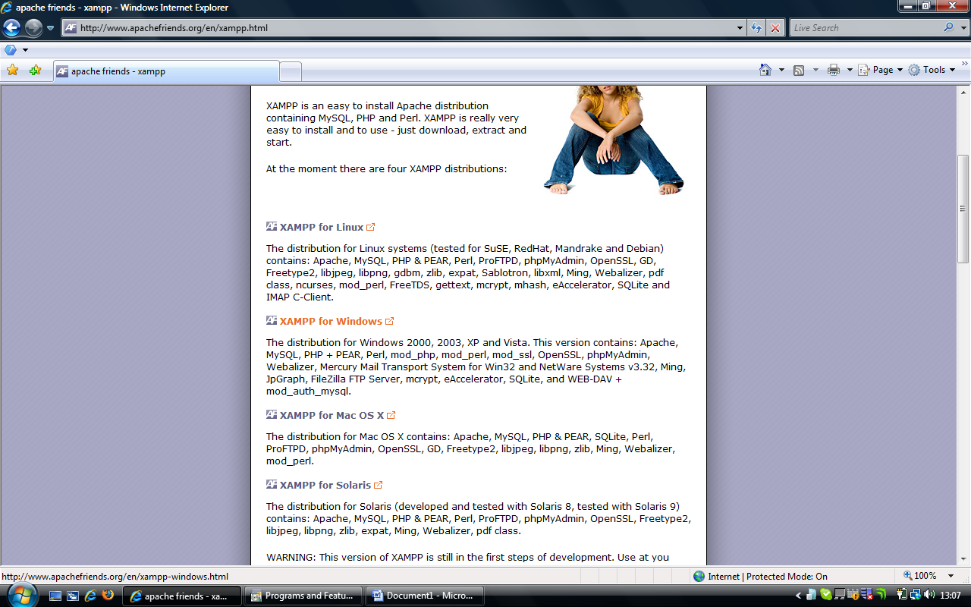

The windows version can be found here (XP/ VISTA and Windows 7), and then the XAMPP for Windows page will load

If you can’t install a windows version, the process is approximately the same, the only direct difference is that later, during setup of Xerte, the quick XAMPP setup option is PC only. Non-PC users should follow the full path.

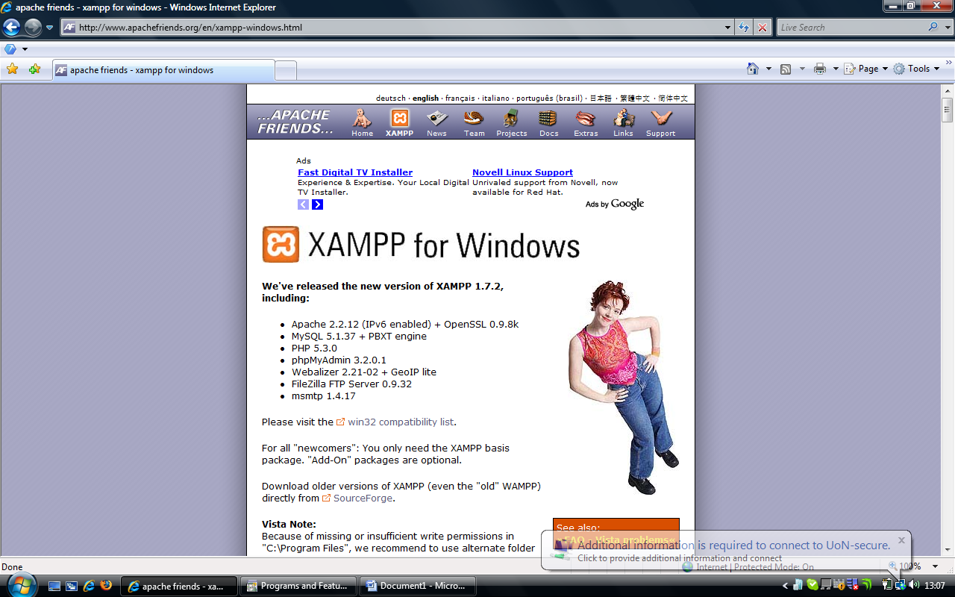

Scroll down the page.

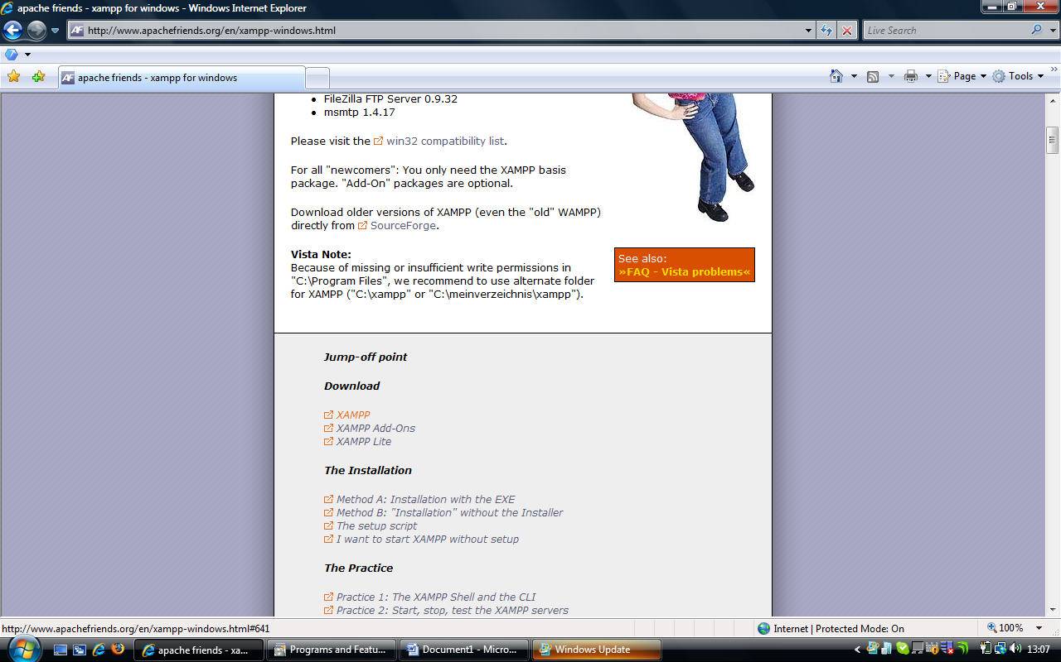

Select XAMPP here, the page will then jump down, and select self-extracting archive

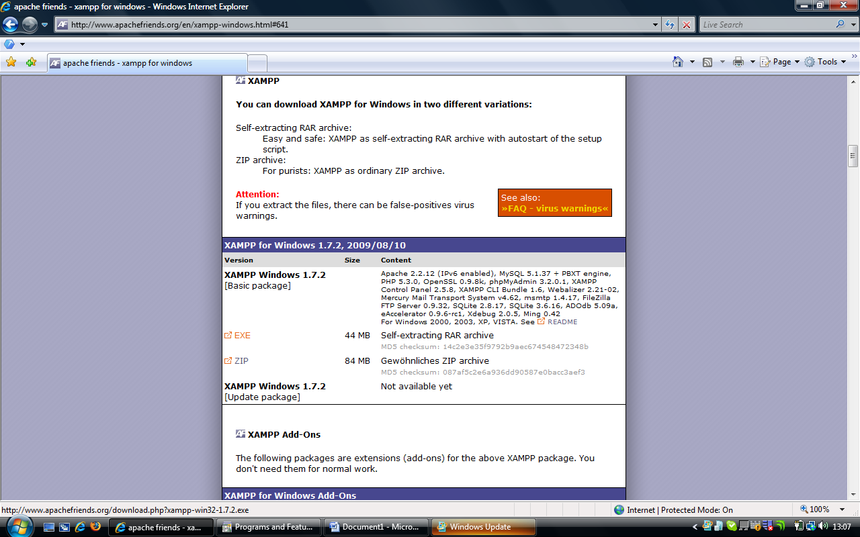

You will then be taken to the download page. Once you get here, the download should start automatically. If not, left click on “direct link”.

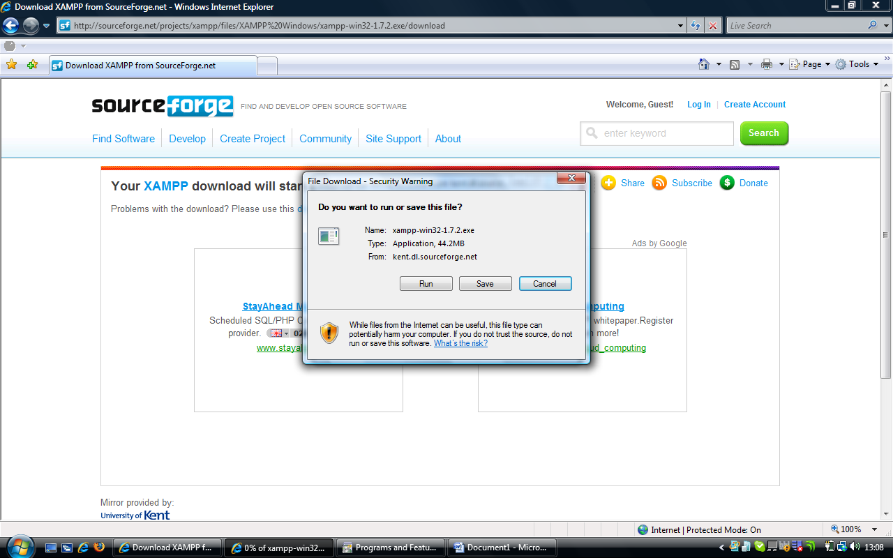

The download should now start as shown above. Left click on run.

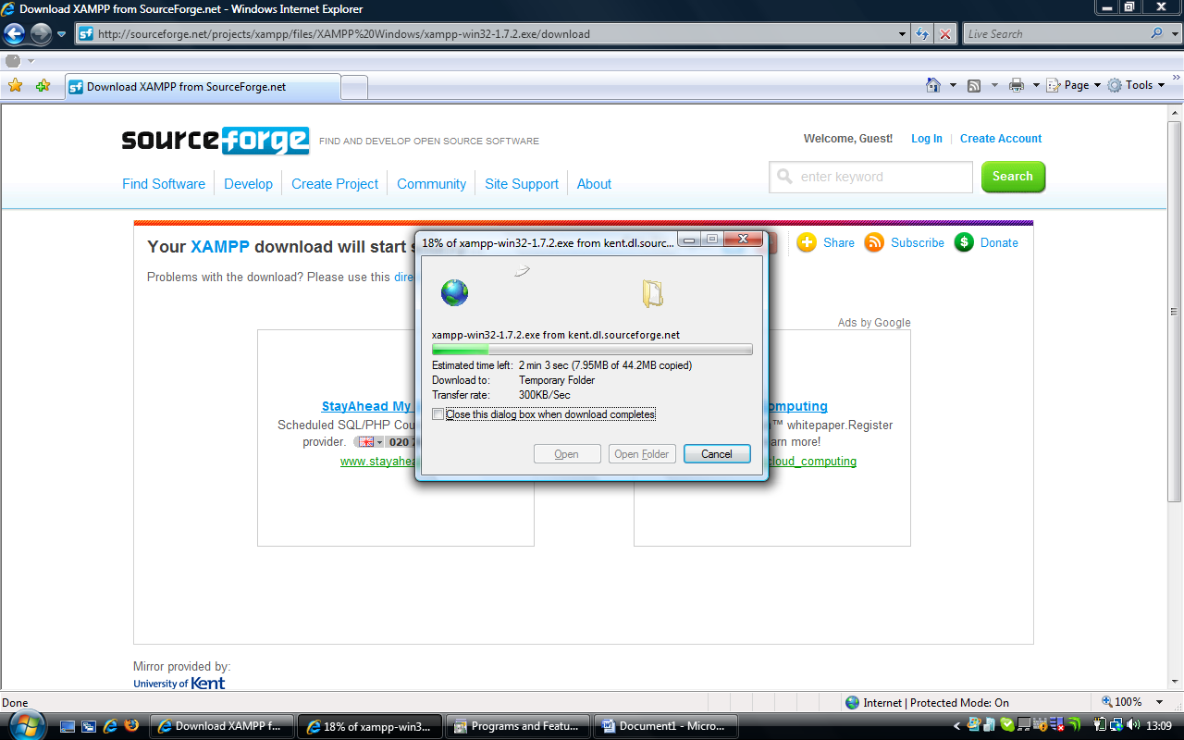

The download will now progress.

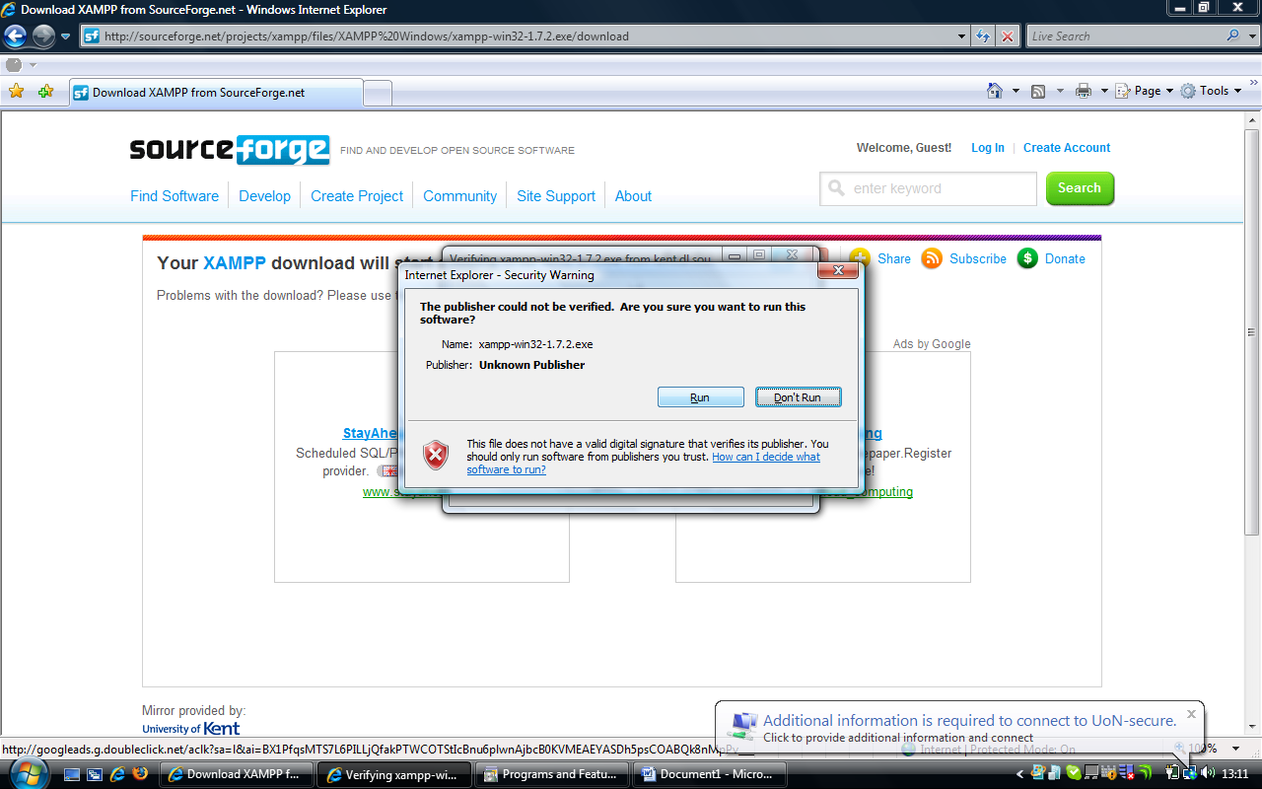

Once the download has finished, left click on run

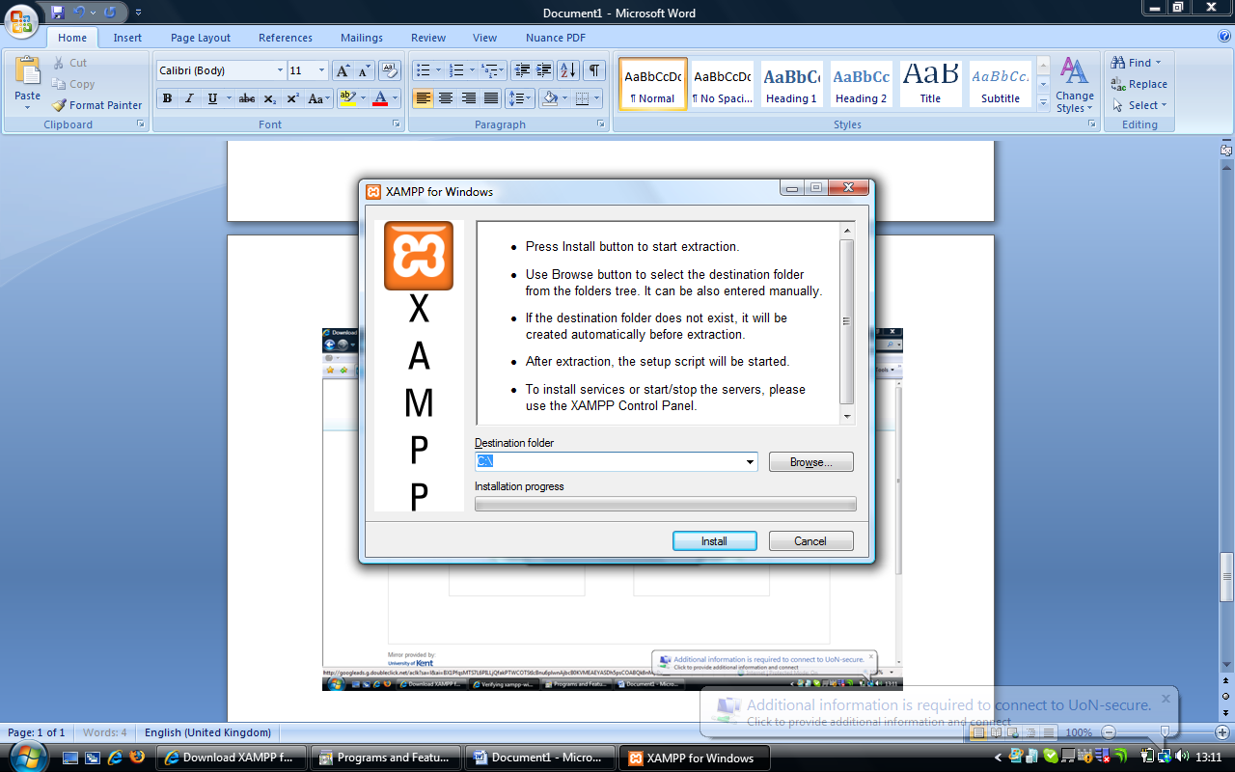

Now XAMPP has started to download, choose “C:\” as the destination folder.

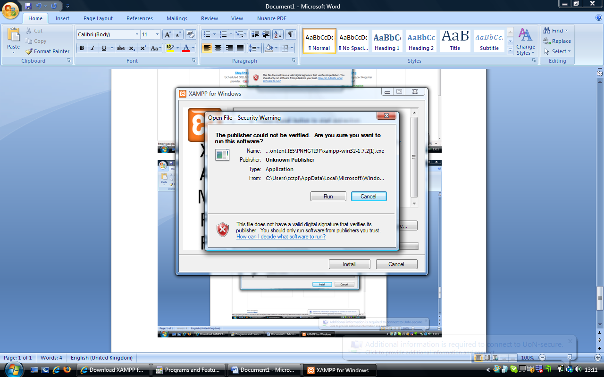

If you receive this message click on run. You may need administrator rights on this PC to install software. If you are unsure please contact your IT Support.

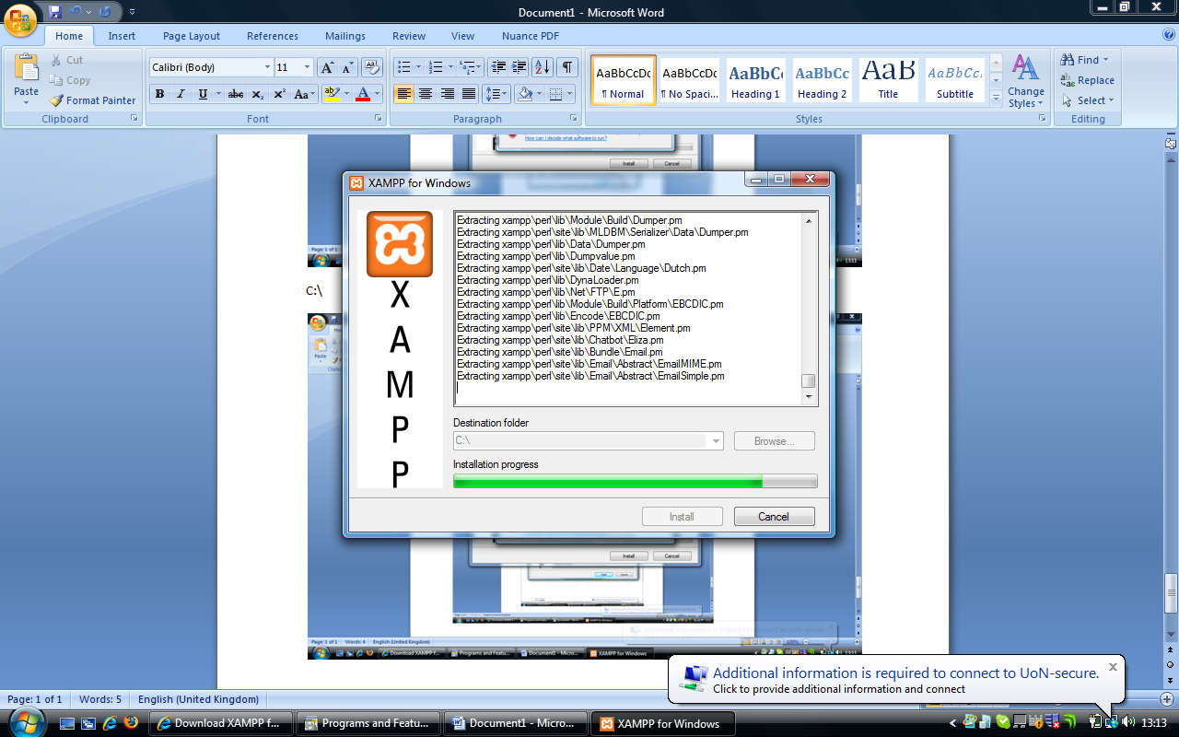

XAMPP will then install

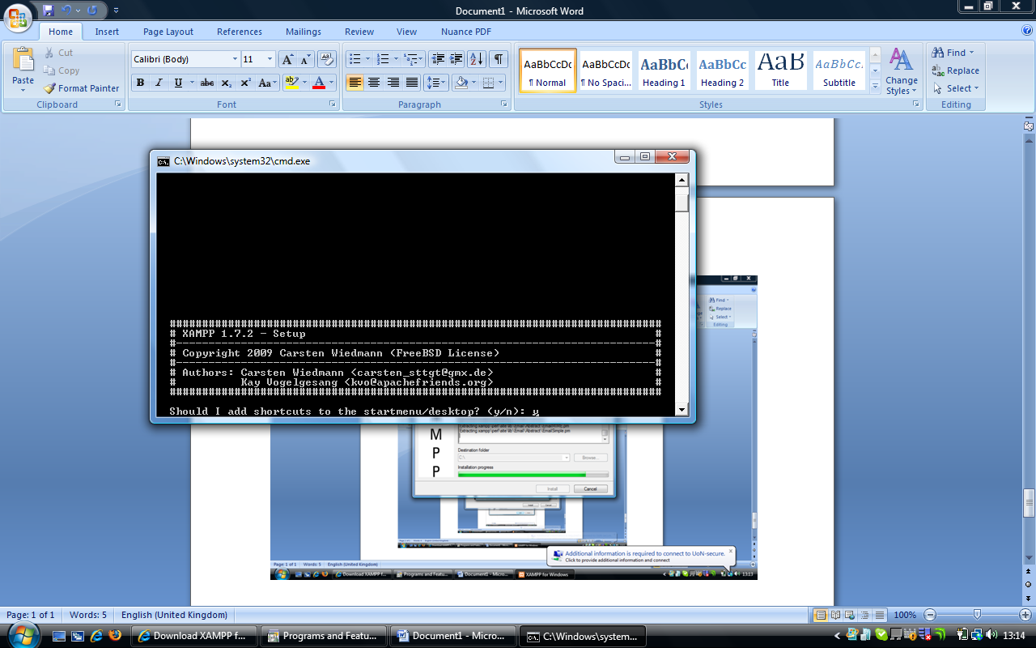

Once XAMPP is finished it will try to configure itself according to your preferences.

At the prompt, “To add shortcuts” press y then return

At the prompt “Should I proceed” press y then return

At the “drive letters” prompt, press y then return

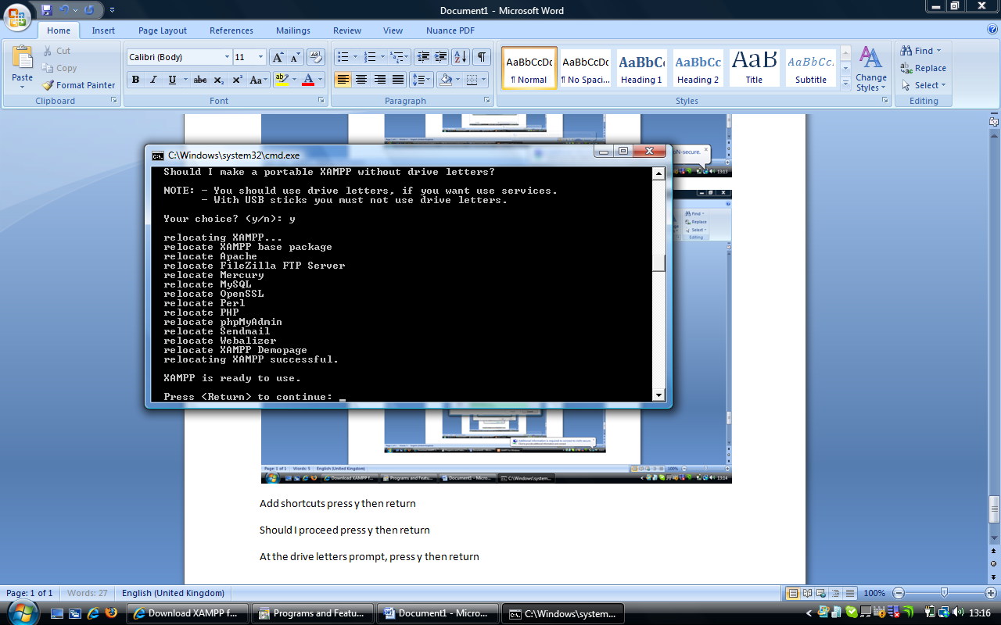

On this screen, press return

Then wait for the question about locations, then press return again

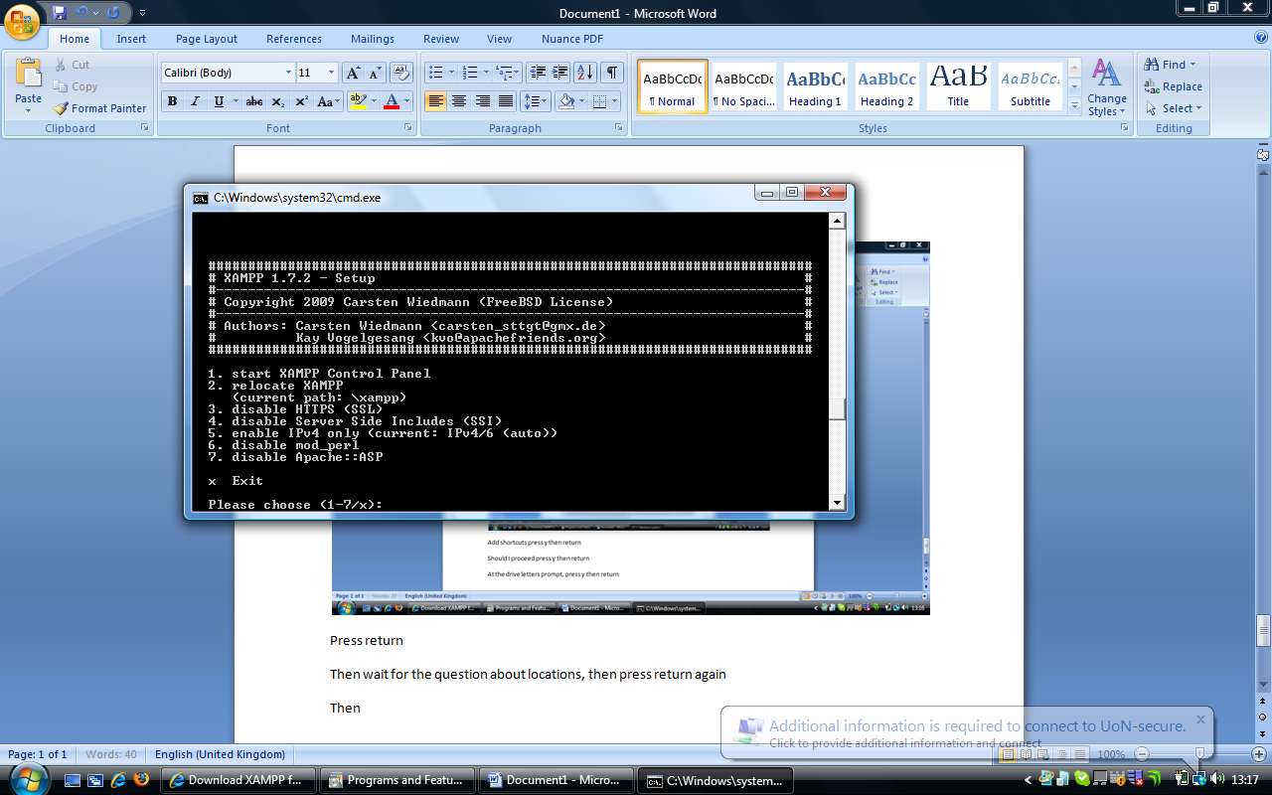

Then press 1, then press return, which will start the XAMPP Control Panel, which will appear as so

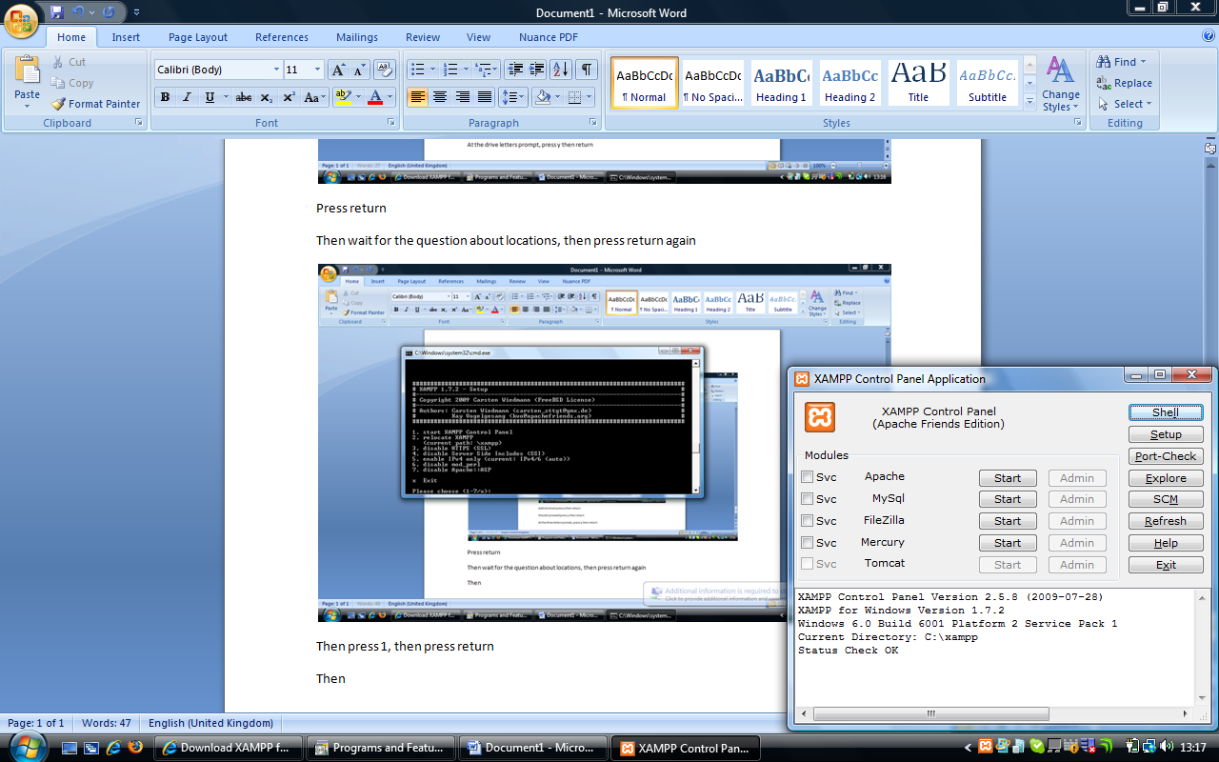

Then click on the start button next to apache

Then click on the start button next to mysql

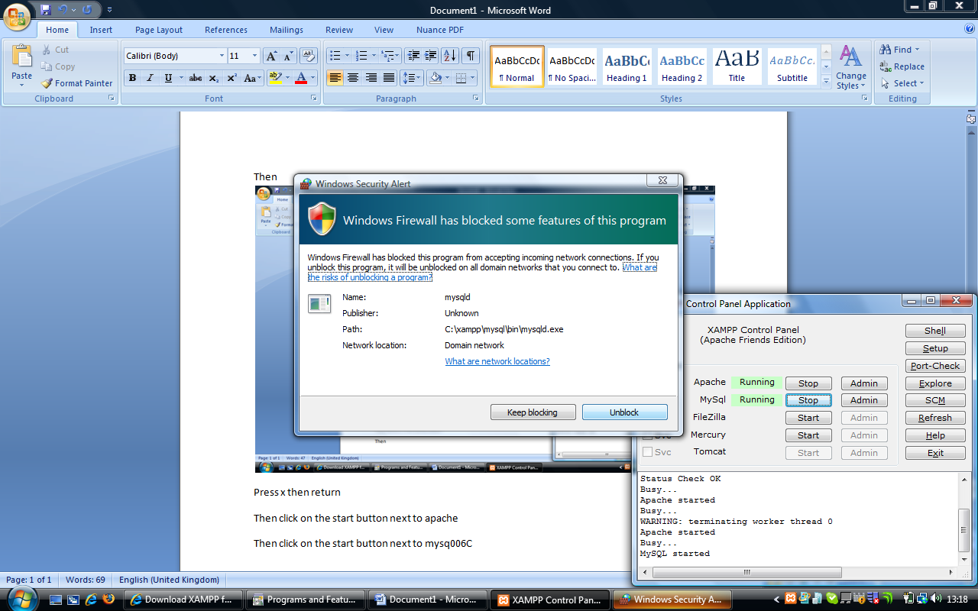

You may get messages like this, click on unblock.

Finally, click back in the black window, and press x then return

Then go to the Xerte Community website (<http://www.xerte.org.uk>) and select Download Xerte On-line Toolkits from the right hand side. This will then offer you the chance to download the zip.

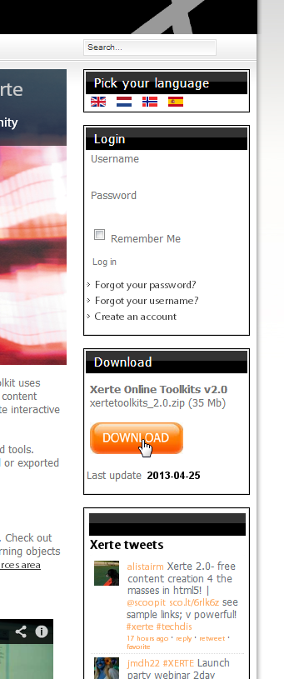

You will need to register to be able to download the .zip file. After you have logged in this will take you to the actual Download page.

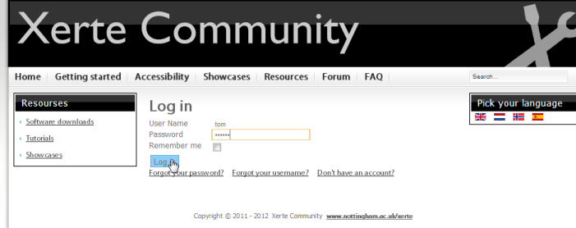



Accept the download by clicking on “save”, then opt to save it to “c:\xampp\htdocs\xertetoolkits\”

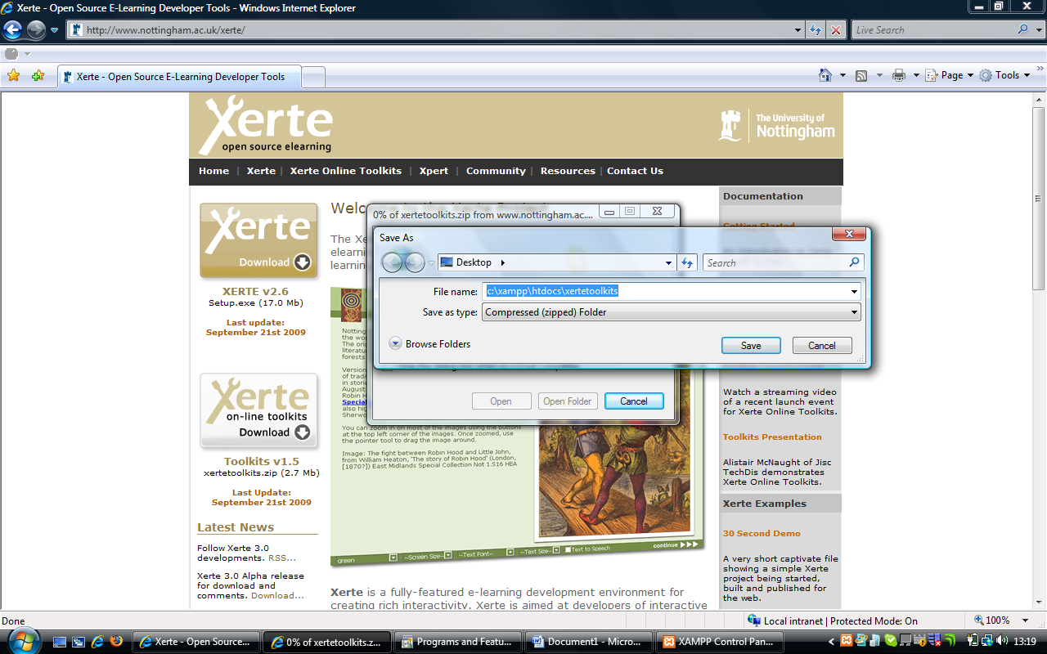

Once the download has finished, navigate to c:\xampp\htdocs\xertetoolkits\

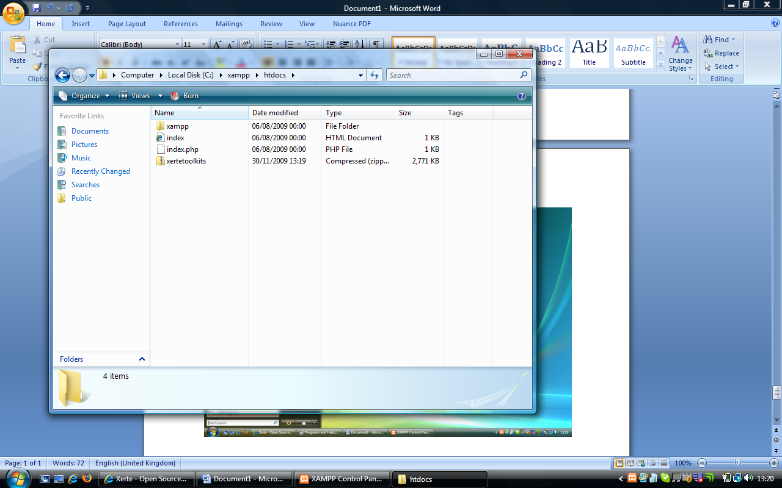

Right click on the zip file, and select “Extract all”

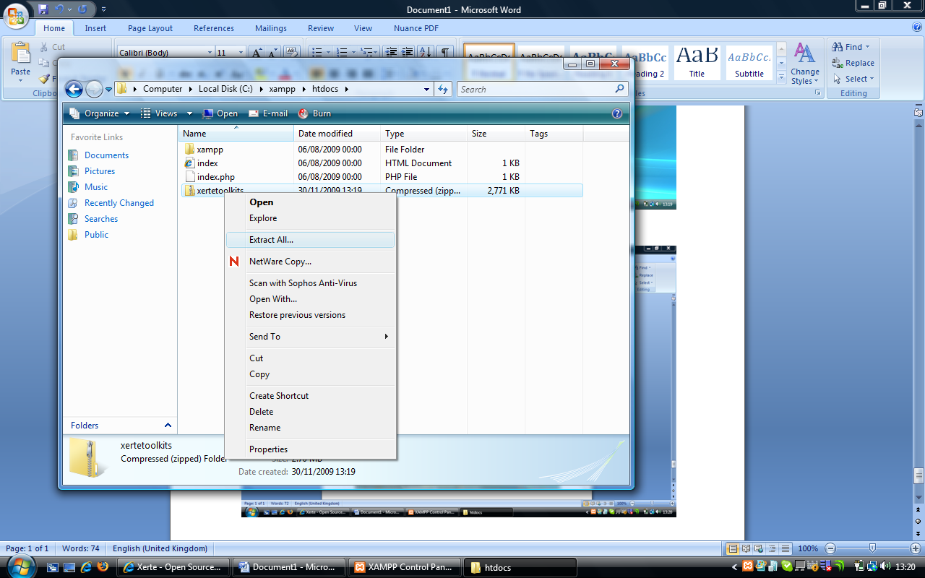

When prompted, make sure the value shown below is “c:\xampp\htdocs\xertetoolkits”

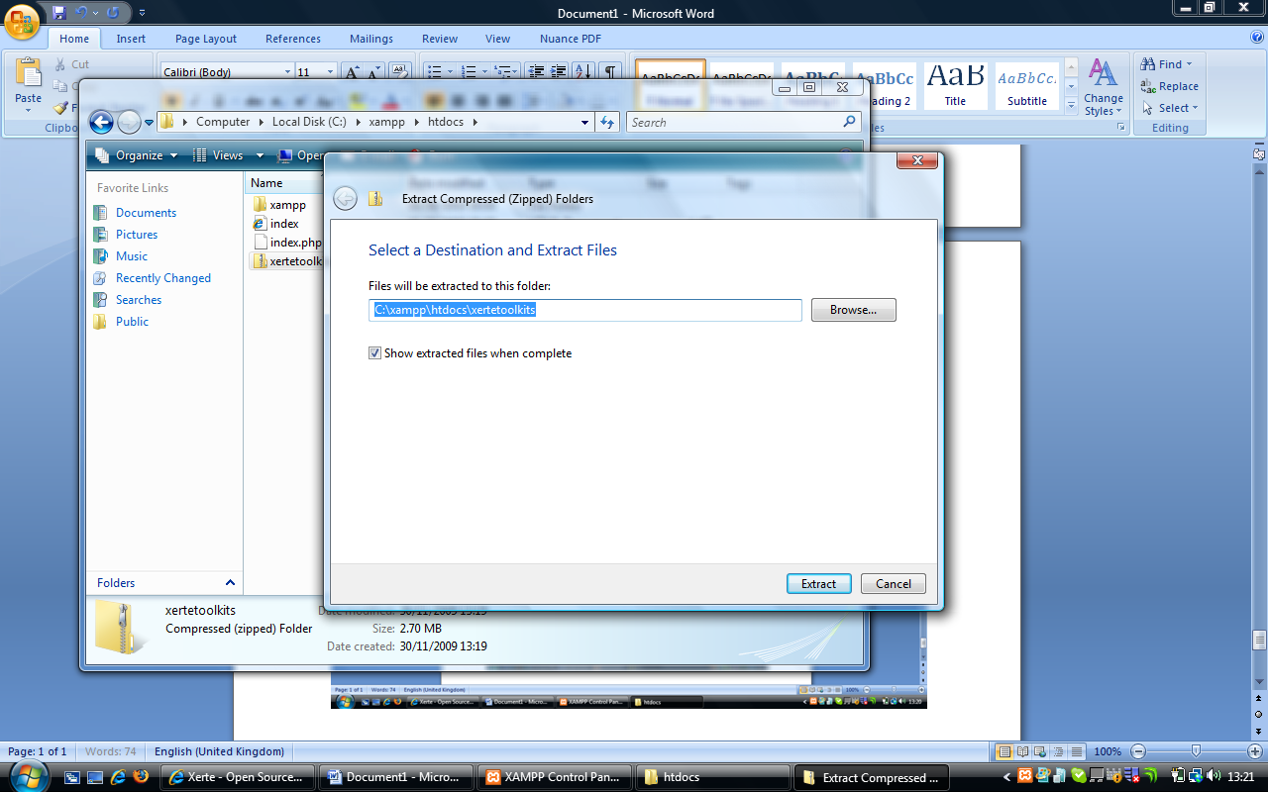

The extraction will then run, and when it is finished you should see a screen like below.

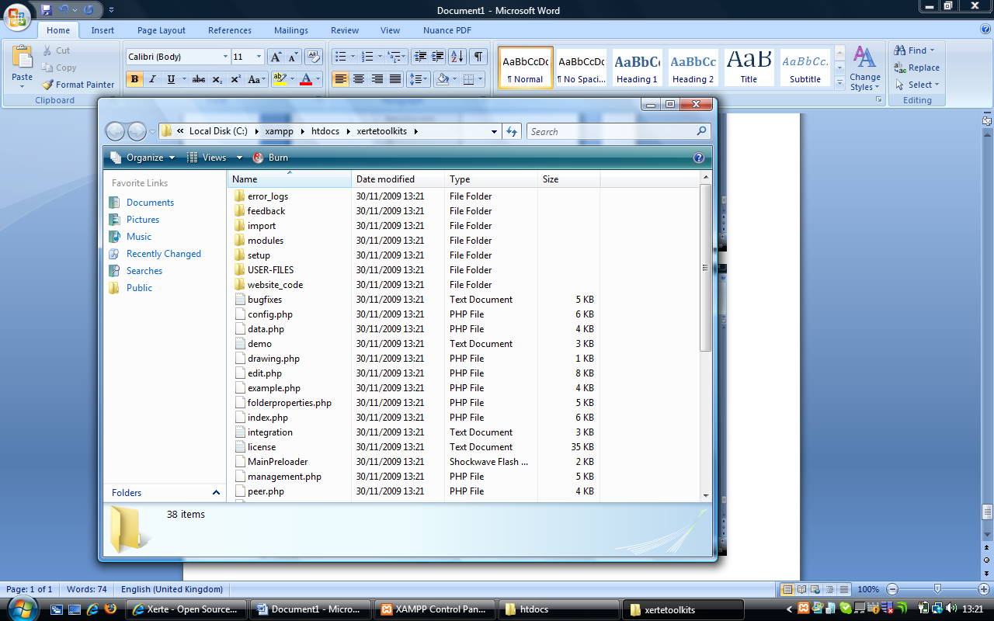

Then start a web browser, and then visit this address

[**http://localhost/xertetoolkits/setup/**](http://localhost/xertetoolkits/setup/)

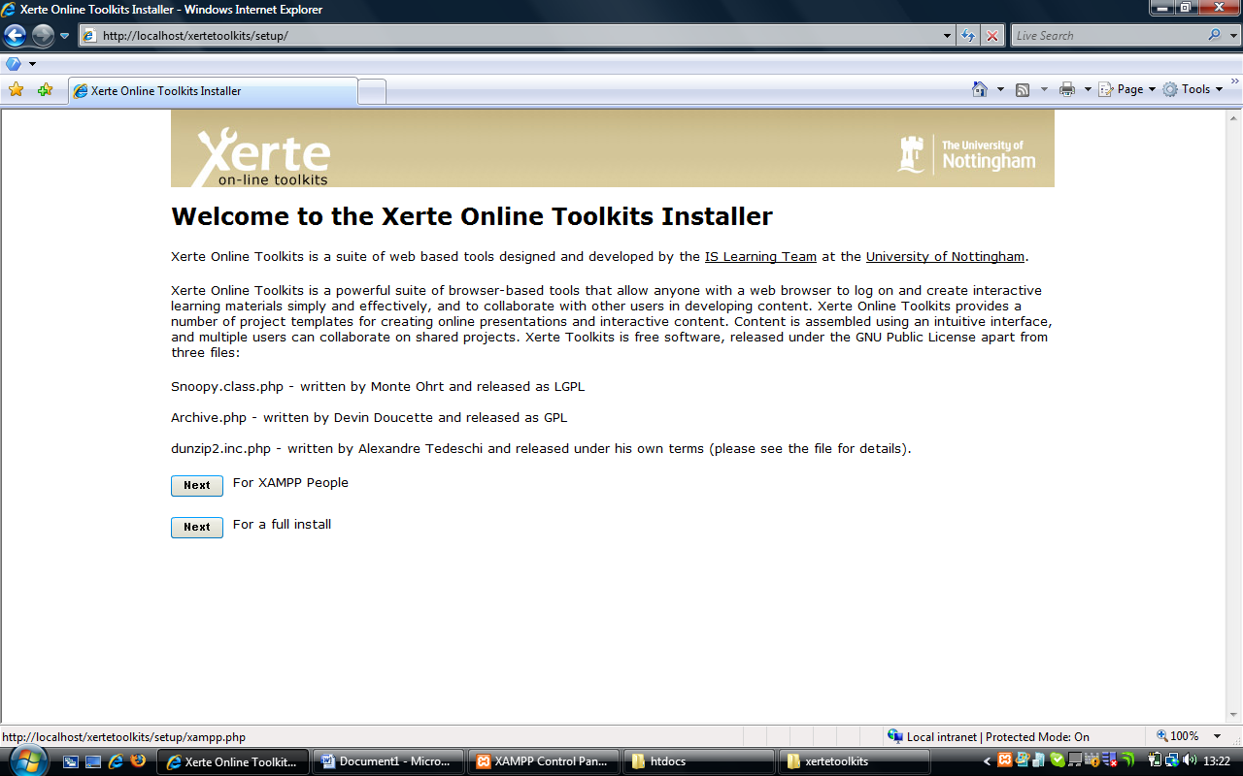

You should see this screen, and you should click on XAMPP

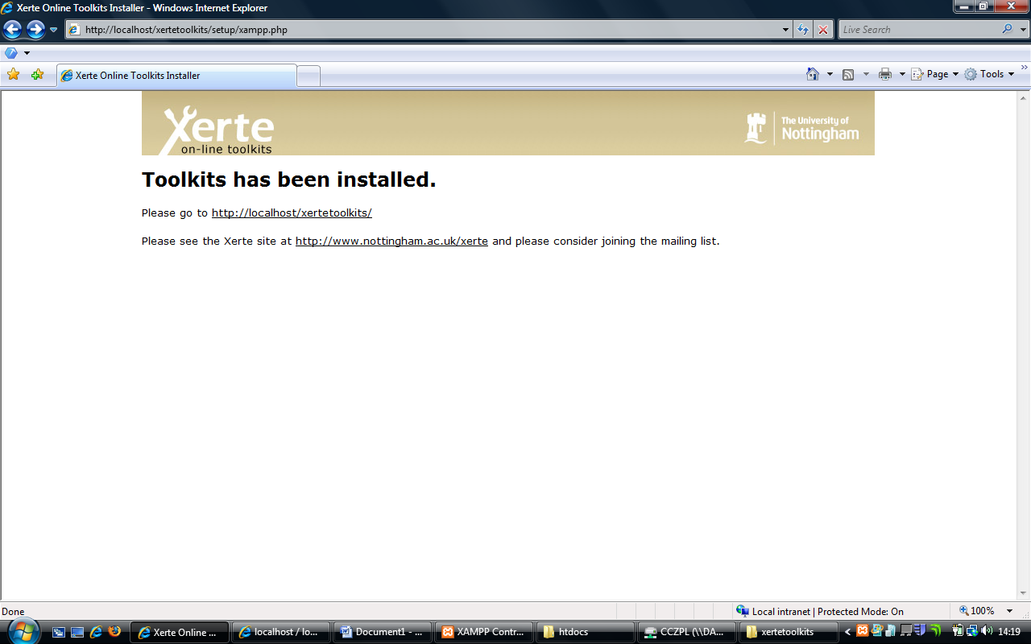

You should then receive this screen, so click on the first link, and you should see the screen below.

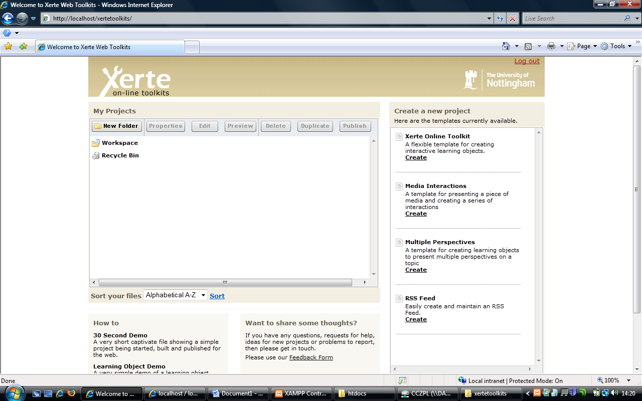

A local install with an existing version of XAMPPIf you installed XAMPP into C:\xampp\htdocs, and have not altered your MYSQL root password then you can proceed as above, as effectively your install is the same.

If you have altered these settings, then you have to proceed as if this was a full install and take the non-xampp route.

# Installing Xerte Online Toolkits on a Web Server or Existing XAMPP

If you don’t have access to a windows PC to install your software on, then you have to proceed as if this was a full install and take the non-xampp route. The final page has a lot of variables, but people using it locally on a standalone unit, please do the following.

Start by downloading the zip. Go to the Xerte Community website (<http://www.xerte.org.uk>) and select Download Xerte On-line Toolkits from the right hand side. This will then offer you the chance to download the zip.



You will need to register to be able to download the .zip file. After you have logged in this will take you to the actual Download page.





Accept the download by clicking on “save”.



Once the download has finished, extract the zip file’s contents to a temporary folder. Then make a new folder on your webserver and then take the files / folders and place them in that folder on the file system that acts as your webserver. For XAMPP Installs, this is usually “htdocs”.

Once you have down this, open a new web browser and navigate to <http://(your> web host)/the folder you created earlier/setup. You should see this screen, click on full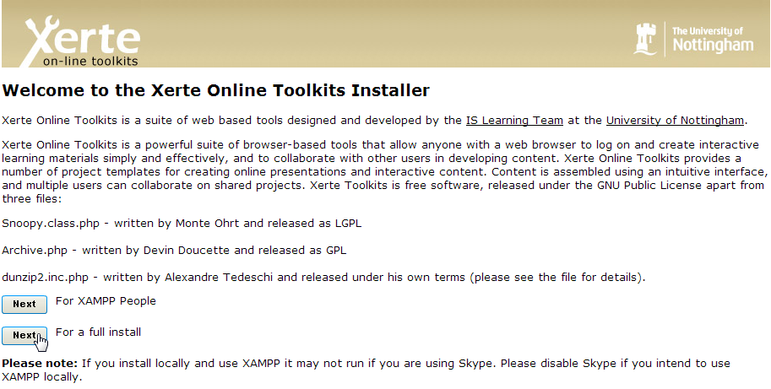

You will then see this screen

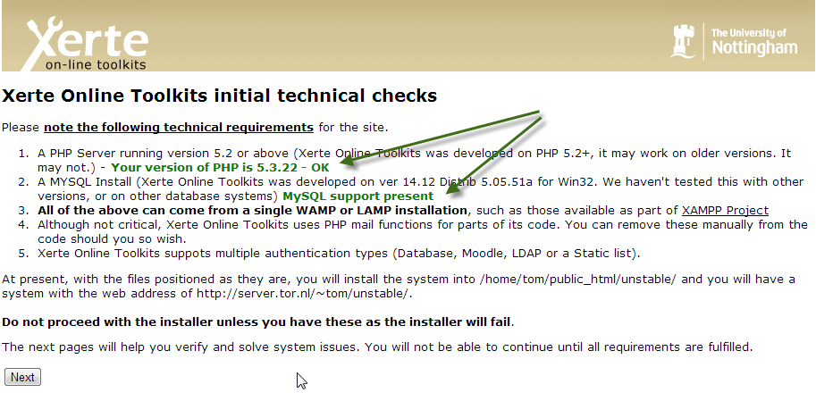

The version of PHP os checked, and whether your php installation supports MySQL. If these conditions are not met, you’ll get some pointer on hor to correct that. If everythings seems to be in order, press ‘Next’.

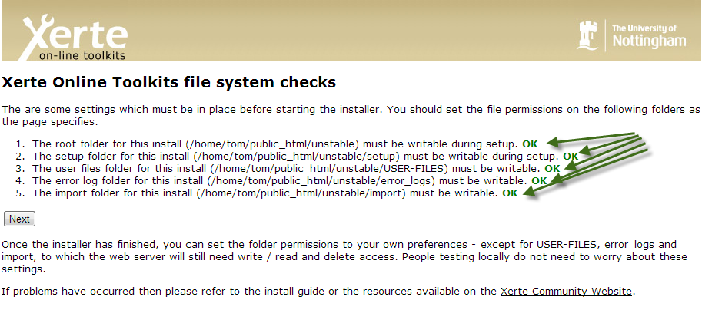

If something is not OK, you will be notified of that in RED and you will not be able to continue, until you remedy the situation. After fixing the reported issues, you can press ‘Try again’ to continue the installation. 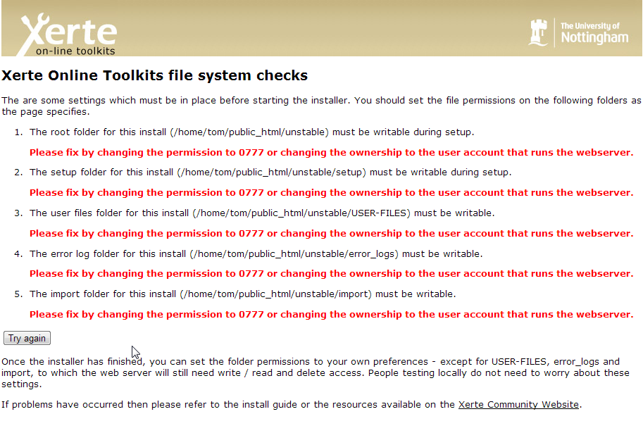

In the next few pages, some of the features tested are not always required. In that case the information is shown in BLUE. You will be able to continue in those cases.

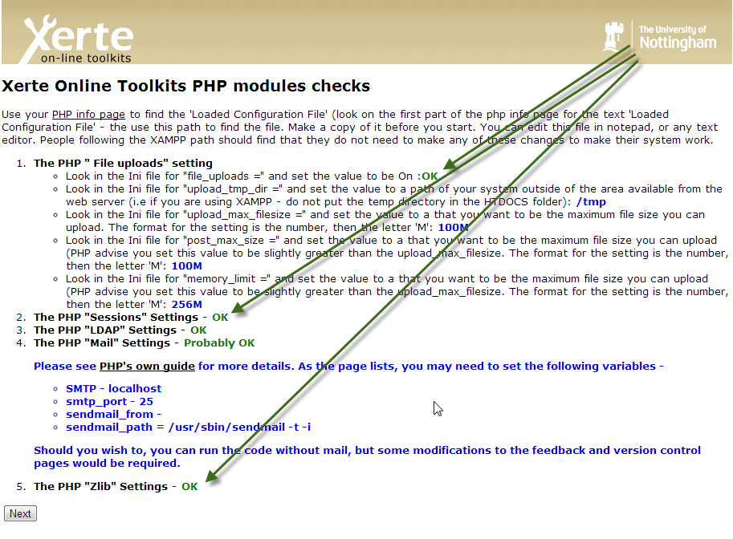

After all the checks, the actual installation is started:

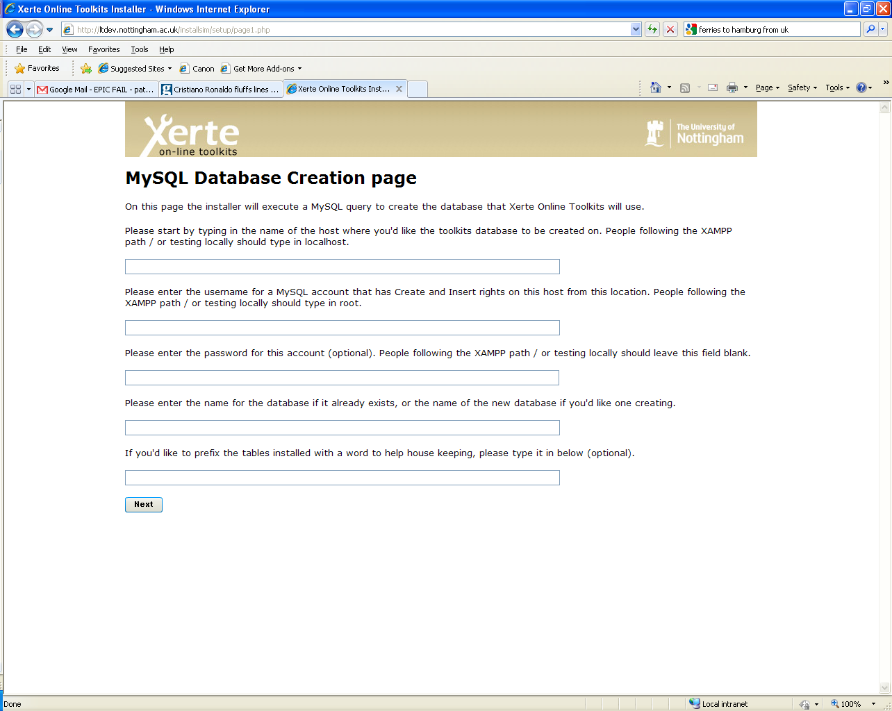

**1**

**2**

**3**

**4**

**5**

**In Box 1** – The name of the host where the mysql server is running. Normally localhost, but this varies between providers. Look at the information of your hosting package for the correct value.

**In Box 2** – Give the name of the mysql account that has the right to create a database. If you’re using XAMPP this usually is ‘root’. Check the information of your hosting provider. In some cases you cannot create databases yourself, but one is created for you. In that case enter the accountname of that has control over that database, and enter the name of the database in Box 4.

**In Box 3** – Give the password of the account you selected in Box 2. For XAMPP this usually is empty, i.e. no password is set.

**In Box 4** – If your hosting package allows you to create databases, select an appropriate name for the mysql database. For example ‘Toolkits’. Sometimes your hosting provider gives you the name of a database. Select that here.

**In Box 5** – If you have been given a single database, and you want to use that database for more web applications you can enter a prefix to add before all the table names. Normally you can leave this box empty.

When you have entered these values click “Next”. Clicking next will attempt to create the database, if this fails it will give you error messages on the next page.

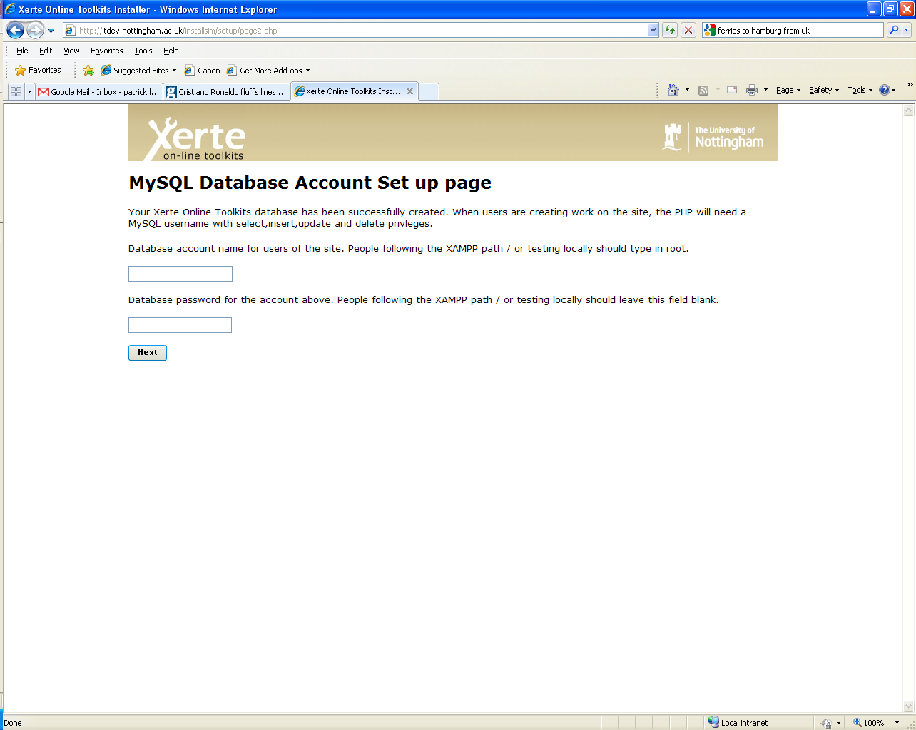

**1**

**2**

On this page, you will enter an account which the site will use to connect to the database. Xampp people can use root as the account name, and leave the password blank.

**In Box 1** – Put the name of the MySQL account you wish to use, normally the same as Box 2 on the previous page.

**In Box 2** – Put the password for this account.

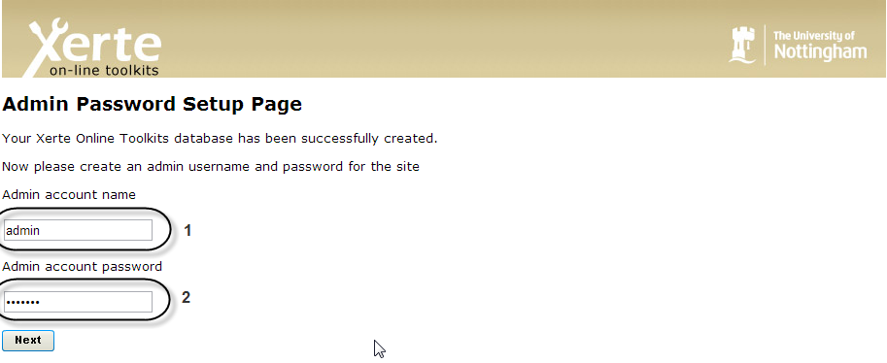

**IMPORTANT**

In this page you setup the adminaccount, and the admin password for the management.php page. Don’t forget to write down the values you entered here.

When happy with these values, please click next. This will take you to page 4 of the installer.

Ignore all the values on this page for now, and scroll down and click submit query.You can change all the values later in the management page. All being well, your site will now install.

People who have not followed the XAMPP path will now need to do the following.

Then you can go to http://(path to website)/toolkits and use your site. Mac or Linux users may find that localhost is suffixed with a port number and so the link presented there will not work.

## What will and won’t work on local installs

### Properties tab

Access – Password protected will not work, Public will not provide any great benefit as the link will only work on your computer.

Shared Settings – This will not work as a local install only has one user.

RSS – Will work, but the links are not distributable as the link will only work on your computer.

Open Content – Will work, but the links are not distributable as the link will only work on your computer.

Peer Review – Will work as a link, but the email function will not, and the link should not be distrubted as the link will only work on your computer.

XML – Will work, but the links are not distributable as the link will only work on your computer.

### Folder properties tab

RSS feed for this folder - Will work, but the links are not distributable as the link will only work on your computer.

### Workspace Properties tab

My details – These will not reflect who you are

My Feeds – Will work, but the links are not distributable as as the link will only work on your computer.

# Site page of management.php and Page 4 of installer

When happy with these values, please click next. This will take you to page 3 of the installer. Page 3 contains a series of values you should enter to ensure your site works.

|  |  |  |  |
| --- | --- | --- | --- |
| **Setup: Page 3 Values** | | | |
| Variable Name | Purpose | Default Value | Change? |
| The **site url** | This is the URL of the site - changing this will not change the URL | The installer will work this out for itself for each site | Do not change this unless it is obviously wrong |
| The **site title** | This is the HTML title tag content | “Welcome to Xerte Online Toolkits” | Should you wish to |
| The **site name** | This is part of index.php and the RSS and Syndication feeds | “Xerte Online Toolkits” | Should you wish to |
| The **site logo** | The logo in the top left, as you can currently see on the installer page | website_code/images/xerteLogo.jpg | You can change this, but this function does not upload an alternative. You would need to manually upload a file and then place its path into the form field supplied. |
| The **organisational logo** | The logo in the top right, as you can currently see on the installer page | website_code/images/UofNLogo.jpg | You can change this, but this function does not upload an alternative. You would need to manually upload a file and then place its path into the form field supplied. |
| The **Welcome message** | The welcome prompt displayed on the home page after logging in | “Welcome to Xerte Online toolkits” | Should you wish to |
| The **site text** | The welcome prompt on the page that prompts for logging in | “Welcome to the toolkits front page, developed by the University of Nottingham” | Should you wish to |
| The **news text** | Html for the small pod below the login box | “<p class="news_title">Other resources</p><p class="news_story"><a href="">Site 1</a></p><p class="news_story"><a href="">Site 2</a></p><p class="news_story"><a href="">Site 3</a></p>” | It is advised that you alter this code to be relevant your install, but this can be done at a later date. |
| The **copyright message** | Copyright message that appears on the login page and the logged in page | “© Copyright University of Nottingham 2008” | This should be left in place |
| The **demonstration page** | A page containing a small training video | modules/xerte/training/toolkits.htm | Please leave this in place unless you can provide an alternative |
| The **form string** is | Used on the login page to draw part of the screen | “<html><body><center><p><form method="post" action=""><p>Username <input type="text" size="20" maxlength="12" name="login" /></p><p>Password <input type="password" size="20" maxlength="36" name="password" /></p><p><input type="image" src="website_code/images/Bttn_LoginOff.gif" onmouseover="this.src='website_code/images/Bttn_LoginOn.gif'" onmousedown="this.src='website_code/images/Bttn_LoginClick.gif'" onmouseout="this.src='website_code/images/Bttn_LoginOff.gif'" /></p>”. | Can be changed if required but may affect page layout / function |
| The content of **pod one** | Content for the left most pod on the logged in page | “p class="news_title">How to</p><p class="demo"><a href="javascript:alert('Sorry. This is not yet available')">30 Second Demo</a><br />A very short captivate file showing a simple project being started, built and published for the web.</p><p class="demo"><a href="javascript:alert('Sorry. This is not yet available')">Learning Object Demo</a><br />A very simple demo of a learning object.</p>” | Can be changed if required but may affect page layout / function |
| The content of **pod two** | Content for the other pod on the logged in page | “<p class="news_title">Want to share some thoughts?</p><p class="general">If you have any questions, requests for help, ideas for new projects or problems to report, then please get in touch.</p><p class="general">Please use our <a href="feedback/" style="color:#000">Feedback Form</a></p>” | Can be changed if required but may affect page layout / function |
| **HTACCESS** setting | Whether or not you are using a .htaccess file on the site - the apache config must allow for overrides | false | If you want to use a .htaccess set this to be true.  You should only set this to true if you are 1 – running apache and 2 – are sure the htaccess will work. Do not set this to be true otherwise. |
| The **integration config path** | for use if integrating with other systems | Empty | Can be left blank during the install. Has specific purposes but for advanced installs |
| The **admin username** | Once the site is installed, running management.php will allow you to change any of the values you have set on this screen | Empty | Put a username in here  Please note this is stored as text |
| The **admin password** | The password for the above account | Empty | Put a username in here  Please note this is stored as text |
| The **allowed upload types for the Media and quota** page | On the properties tab, various media mimetypes are acceptable | text/xml,application/msword,application/x-shockwave-“flash,image/jpeg,image/pjpeg,image/png,image/gif,image/x-png,audio/mpeg,application/vnd.ms-excel,application/pdf,application/vnd.ms-powerpoint,video/x-ms-wmv,text/html,video/mp4,video/avi,audio/wav,text/plain,video/quicktime | You are welcome to add other mime types to this list  These are added into each projects media folder, so will sit on the web server |
| The **RSS Feed** title | Appears as the title of the RSS Feed | “Xerte Online Toolkits” | You are welcome to change this, but if you do, please be certain to make sure you don’t invalidate the RSS. Many RSS feed validators are available. |
| The **institutional publisher** | The value inserted into DC:publisher on the Syndication RSS Feed | “Put your institution's name here” | You are encouraged to change this, but if you do, please be certain to make sure you don’t invalidate the RSS. Many RSS feed validators are available. |
| The **standard syndication** **rights** for the syndicated content | The DC rights for the feed | Creative Commons Attribution - NonCommercial-ShareAlike 2.0 Licence - see <http://creativecommons.org/licenses/by-nc-sa/2.0/uk/> | Please change this to a license your institution is happy with |
| The **standard syndication license** for the syndicated content | The CC license for the feed | Creative Commons Attribution - NonCommercial-ShareAlike 2.0 Licence - see <http://creativecommons.org/licenses/by-nc-sa/2.0/uk/> | a Please change this to a license your institution is happy with. |
| The **module path** | Where the modules live on the web server | modules/ | Should only be changed as part of advanced installs |
| The **website code path** | Is the path to the root of the code used by the website outside of the root | website_code/ | Should only be changed as part of advanced installs |
| The **short file area path** | The short path to the folder which stores a users items | USER-FILES/ | Should only be changed as part of advanced installs |
| The **php library path** | The path to where the PHP libraries live on the webserver | website_code/php/ | Should only be changed as part of advanced installs |
| The **root file path** | The root path for the site | The is set per site by the installer. | Should only be changed as part of advanced installs, or if it is obviously wrong |
| The **import path** | Where imported files are temporarily held | The is set per site by the installer. | Can be left as is, but you should note this is within the root of the website and it may be more secure to move it outside |
| The **play edit preview query** | A single query used by play, edit and preview pages | select " . $xerte_toolkits_site->database_table_prefix . "originaltemplatesdetails.template_name, " . $xerte_toolkits_site->database_table_prefix . "logindetails.username, " . $xerte_toolkits_site->database_table_prefix . "originaltemplatesdetails.template_framework, " . $xerte_toolkits_site->database_table_prefix . "templaterights.user_id, " . $xerte_toolkits_site->database_table_prefix . "templaterights.folder, " . $xerte_toolkits_site->database_table_prefix . "templaterights.template_id, " . $xerte_toolkits_site->database_table_prefix . "templatedetails.access_to_whom from " . $xerte_toolkits_site->database_table_prefix . "originaltemplatesdetails, " . $xerte_toolkits_site->database_table_prefix . "templaterights, " . $xerte_toolkits_site->database_table_prefix . "templatedetails, " . $xerte_toolkits_site->database_table_prefix . "logindetails where " . $xerte_toolkits_site->database_table_prefix . "templatedetails.template_type_id = " . $xerte_toolkits_site->database_table_prefix . "originaltemplatesdetails.template_type_id and " . $xerte_toolkits_site->database_table_prefix . "templatedetails.creator_id = " . $xerte_toolkits_site->database_table_prefix . "logindetails.login_id and " . $xerte_toolkits_site->database_table_prefix . "templaterights.template_id = " . $xerte_toolkits_site->database_table_prefix . "templatedetails.template_id and " . $xerte_toolkits_site->database_table_prefix . "templaterights.template_id="TEMPLATE_ID_TO_REPLACE" and role="creator" | Should only be changed in advanced installs |
| The **error log** | Where error logs are written to | error_logs/ | You can move this should you wish to, but ensure it remains writable to |
| The **email error list** | A list of people set up to receive email messages when an error is generated | blank | Please set a list of semi-colon separated email address here to receive error messages when the site generates an error (A badly set up site could generate a lot of errors). |
| The **error log message** | Whether or not error logs are created | false | A decision for the site administrator.  Can be toggled to help debugging.  A badly set up site could generate a lot of errors. |
| The **email error** message | Whether or not the site should send error messages or not | false | A decision for the site administrator.  Can be toggled to help debugging.  A badly set up site could generate a lot of errors. |
| The **maximum error size** | How big an error log file before older error messages are pushed out | 10 | You can set this to be higher, but appreciate higher values will increase the disk space used by the service |
| The **ldap host** | The LDAP host you can authenticate to | Blank | This must be set unless you have another authentication service |
| The **ldap host** | The port on the above host | Blank | This must be set unless you have another authentication service |
| The **ldap password** | A password that the account listed in the Ldap bind can use to authenticate with. Lighter **LDAP** does not need this password | Blank | This must be set unless you have another authentication service |
| The **ldap base** | A string, containing the ldap host but in a form that can be used to run an LDAP query, such as DC=ad,DC=hostname,DC=com | Blank | This must be set unless you have another authentication service |
| The **ldap bind** | A string used in the ldap query, but provides information on authenticating to LDAP and also which parts of the LDAP system to search when trying to authenticate a user. | Blank | This must be set unless you have another authentication service |
| The **first LDAP filter** | Part of the LDAP Process to tell the search query what fields to search for | “sAMAccountName” - this is a widely used value in academic institutions. You may wish to change this to something more suitable. | This must be set unless you have another authentication service |
| The **second LDAP filter** | Another part of the LDAP searching process | “cn=”, this is a widely used value in academic institutions | This must be set unless you have another authentication service |
| The **Peer form string** | Used on the peer review page to make a login box | “<html><body><center><p><form method="post" action=""><p>Password <input type="password" size="20" maxlength="36" name="password" /></p><p><input type="image" src="website_code/images/Bttn_LoginOff.gif" onmouseover="this.src='website_code/images/Bttn_LoginOn.gif'" onmousedown="this.src='website_code/images/Bttn_LoginClick.gif'" onmouseout="this.src='website_code/images/Bttn_LoginOff.gif'" /></p>” | You are welcome to change this but appreciate it may affect layout and site function |
| The **flash save path** | Used by the Xerte editor to save its XML | /xerte/engine/save.php | Should only be changed as part of advanced installs  You are welcome to change the code inside |
| The **flash upload path** | Used by the Xerte editor to upload files | upload.php?path= | Should only be changed as part of advanced installs  You are welcome to change the code inside |
| The **flash preview check path** | Used by the Xerte editor to check if a file exists | modules/xerte/engine/file_exists.php | Should only be changed as part of advanced installs  You are welcome to change the code inside |
| The **flash flv skin** | Used by the Xerte editor to display a preview of an FLV | modules/xerte/engine/tools/SteelOverAll.swf | Should only be changed as part of advanced installs  You are welcome to replace this. |
| The **site email account** | Email account which receives feedback from the feedback page | Blank | Recommended you set this |
| The **site email headers** | Used to format the emails sent by the peer review page | Blank | Use a * to denote a \n in the email headers.  It is recommended you set this |
| The **site email to add to username** | The system only stores the username provide by LDAP.  Use this value to append the username to form an email address.  This is used by the lockfile code, and on the peer review page | Blank | It is recommended you set this  You don’t need to use the @ symbol |
| The **site's proxy host** | This is used by various parts of the code to get resources from the internet. It should be a valid proxy service. | Blank | It is recommended you set this |
| The **site's proxy port** | The port on the above host | Blank | It is recommended you set this |

Once you have decided on these values (remember you can go back and change them using management.php) click “Submit query”.

A successful installation should now occur, which will look as such

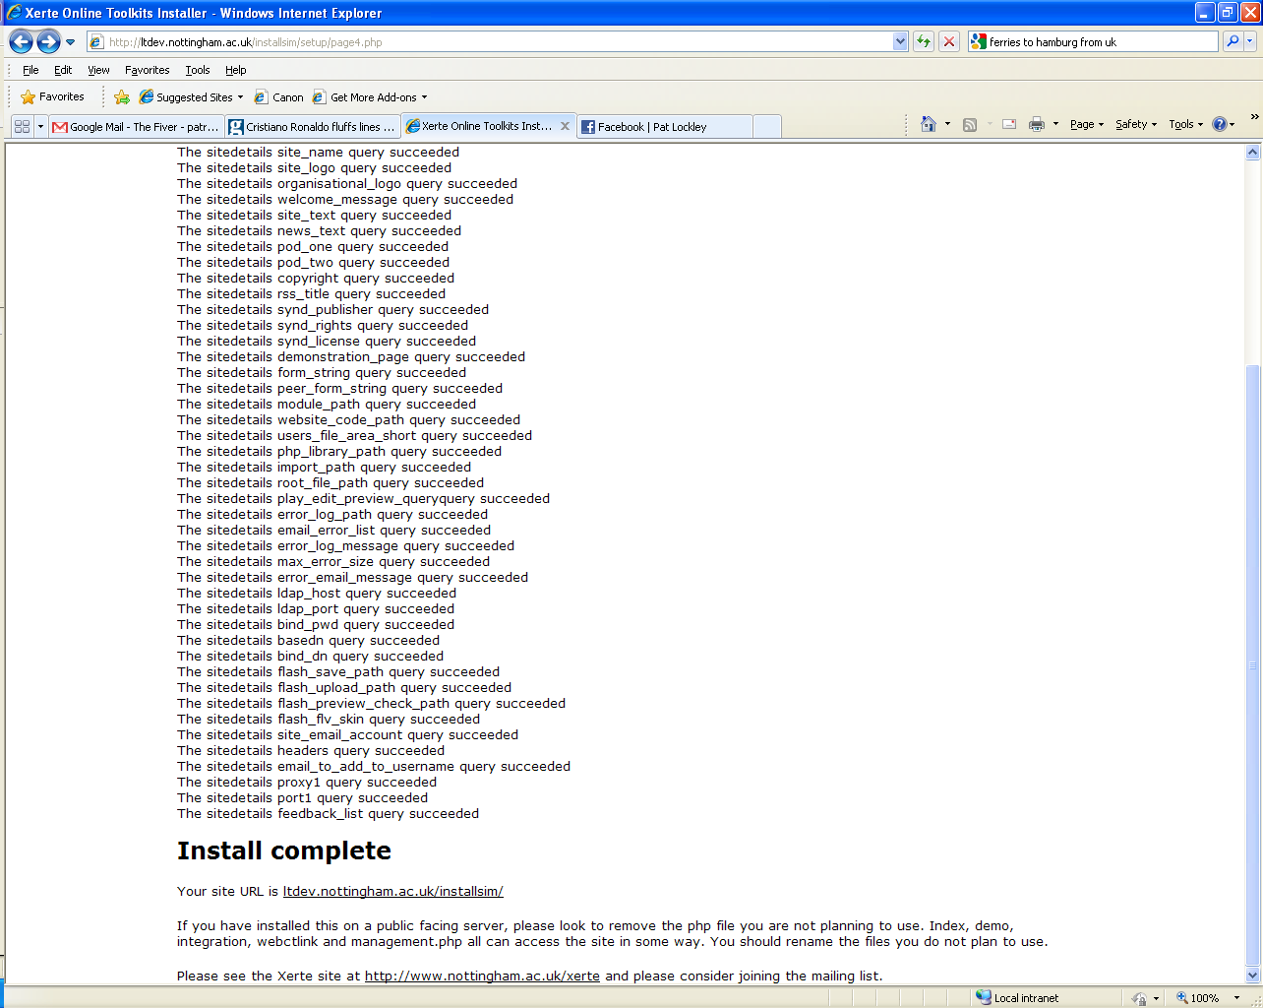

The installer runs, and provides a result for each of the values added to the system.

Any error is reported on an item per item basis.

Your site should now function normally. To change any of the values go to management.php in the root of the site.

# Authentication in Xerte Online Toolkits

Authentication in Xerte Online Toolkits comes in several forms. If you work using a local XAMPP install , then this will all be set up for you. Authentication options are at the moment changed by editing the <root of install>/auth_config.php file.

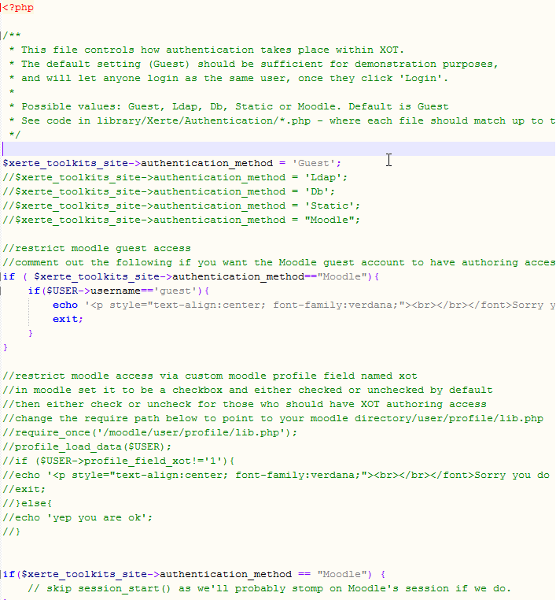

There follows a list of authentication options:

GuestYou will have a page which can access the site without a password or username. It is unsecure however, as it can be ran by anyone with access to the file. Do not use ‘Guest’ on a public web server where anyone could access it unless you have other security measures in place.

LdapThis expects to draw a password and a user name from an LDAP server.

## Db

This will add a table to the database. Users can be managed through the management.php page.

StaticStatic is similar to ‘Guest’ except is has limited support for multiple users. It is not considered suitable for enterprise level usage. Also it is made obsolete by the ‘Db’ authentication method.

Running Xerte Online Toolkits with Authentication from MoodleRon Mitchell has created a patch to allow Moodle users to use Moodle to authenticate users to Xerte Online Toolkits.

This method of authentication integration has been tested with XOT 1.8 and enables authentication integration with the moodle installation on the same server. Specifically it enables integration with the moodle authentication system allowing seamless login from moodle to toolkits. This is achieved by using the moodle session data so at the moment this will not work if moodle and toolkits are installed on separate servers.

Note: this latest integration will only work with XOT 1.8 and above and is not backwards compatible with previous XOT versions. It should however work with any version of Moodle e.g. 1.9x as well as 2.x.

### How this works

Once applied and configured this patch works in the following ways:

1. A user logs in to moodle and then follows a link from that moodle to an installation of toolkits on the same server. The user is automatically logged in to their own workspace in toolkits seeing any previous LO's they have created. If this is their first visit to the toolkits installation their firstname, lastname and username are added to the xerte toolkits database. (This then also allows other users to share learning objects with the new toolkits user via properties > shared settings or to give learning objects via properties > give this project ) This also means that any existing moodle user, or new users registering on moodle, also has access to the linked toolkits installation.
2. A user visits the toolkits installation without first logging in to moodle. They are automatically redirected to login to moodle.

If the toolkits installation is installed as a subdirectory of the moodle directory the user is then automatically redirected back to their own workspace in toolkits.

If the toolkits installation is installed in a separate directory to the moodle directory the user will not be automatically directed back to toolkits but can follow a link to toolkits from the moodle installation or revisit the toolkits url with the same browser to be automatically logged in.

### Installation/Configuration

Please follow these steps carefully.

#### Step 1.

Test your XOT installation before trying to use the moodle integration e.g. install toolkits and use the guest authentication to make sure everything is working - creating, viewing, exporting an LO etc

Note: the different authentication options are enabled/disabled at the bottom of auth_config.php e.g. uncomment //$xerte_toolkits_site->authentication_method = 'Guest'; to test with guest authentication.

#### Step 2.

Either by using the management page or by editing sitedetails in the database add the path to your moodle installation to the integration config path field

e.g. this might be something like the following:

require("/home/youraccountname/public_html/config.php");

For a xampp/maxos install this should be something like:

require("/xampp/htdocs/moodle/config.php");

#### Step 3.

In the XOT auth_config.php comment out //$xerte_toolkits_site->authentication_method = 'Guest'; and uncomment //$xerte_toolkits_site->authentication_method = 'Moodle';

#### Step 4.

View http://yourmoodle/yourxot/ and ensure everything still works. You should be forced to login to Moodle and then returned back to XOT if installed inside the moodle directory. (see how this works above)

Step 5 (optional)

If you wish to restrict authoring access to XOT e.g. not allow all moodle users to author you can easily do so by creating a custom profile field in moodle - see the commented our code at the bottom of auth_config.php

### After installation/configuration

You can verify you have configured the moodle path correctly by visiting your toolkits installation which should redirect you to login to moodle. (see the 'how this works' info above)

### Bugs/feedback

Please send reports of bugs, success or any other feedback to the Xerte mailing list: xerte@lists.nottingham.ac.uk

# Frequently Asked Questions

Q: When I extract the zip file, I receive a lot of duplicate error messages  
A: Make sure that when you unzip, your zip tool ensures the folders are unzipped as well

Q: I get “Page cannot be found” when I try to run setup  
A: You may have another web service running. If you are running a PC, try this guide to disabling IIS - <http://support.microsoft.com/kb/321141>. Only disable IIS if you are certain no other service on your PC uses it. You also need to make sure PHP is running. If your using XAMPP, look at the XAMPP control panel to see if PHP is running.

Q: I get a function “Mysql_connect” does not exist error  
A: You do not have MySQL installed as a PHP module. Install mysql (perhaps using XAMPP) then start again. You need to make sure MySQL is running. If your using XAMPP, look at the XAMPP control panel to see if MySQL is running

Q: On page 5 of the installer I get a series of errors.  
A: You did not make the root folder and/or the setup of your site writable too. As such your database configuration will not have been set up. You will need to start the process again after making the folders writable. You specified the wrong database host and / or password. The account you gave on page 2 lacks insert rights to this database

Q: When I try to log in I get a white screen  
A: You do not have LDAP installed. If you cannot use LDAP to authenticate, consider using one of the other options provided in the authentication section.

Q: I cannot log in as administrator  
A: The administrator account only works on management.php, not index.php  
A: You did not set admin_username and admin_password when setting up the site

Q: I get the following error:  
“Warning: fopen(database.txt) [function.fopen]: failed to open stream:

Permission denied in

/home/httpd/vhosts/schoolict.ch/httpdocs/xertetoolkits/setup/page2.php

on line 98

Warning: fwrite(): supplied argument is not a valid stream resource in

/home/httpd/vhosts/schoolict.ch/httpdocs/xertetoolkits/setup/page2.php

on line 99

Warning: fclose(): supplied argument is not a valid stream resource in

/home/httpd/vhosts/schoolict.ch/httpdocs/xertetoolkits/setup/page2.php

on line 100”

A: You did not set the setup folder to be writable. Restart the process after making this change

Q: The RSS page doesn’t work

A: You need to set a proxy and a proxy port in the management side of things for this to work

Q: When I create a new piece, the editor buttons are greyed out and disabled  
A: You may need to set up new mime types on your server.   
A: Your learning object failed to load – is the USER-FILES folder empty?

Q: I can’t create new items – they only display when I refresh a page  
A: Something in your PHP code is failing, check the sitedetails table to see if root_file_path is ok, or that you have right access to the user-files folder.

Q: None of the play, edit or preview pages work  
A: You may have set up a .htaccess when you can’t use one, or your Apache server has other settings conflicting with the .htaccess used by Xerte Online Toolkits

# Site Management

Managing a Xerte Online Toolkits install can be achieved by using management.php. This is another web based interface stored in the root folder of the install. This feature doesn’t work on standard XAMPP Installs. You will need to set admin_username and admin_password in the sitedetails table for this feature to work properly

Then visit either http://yoursite/management or http://yoursite/management.php to access these panels.

## Using Management.php

### The Main Panel: Site

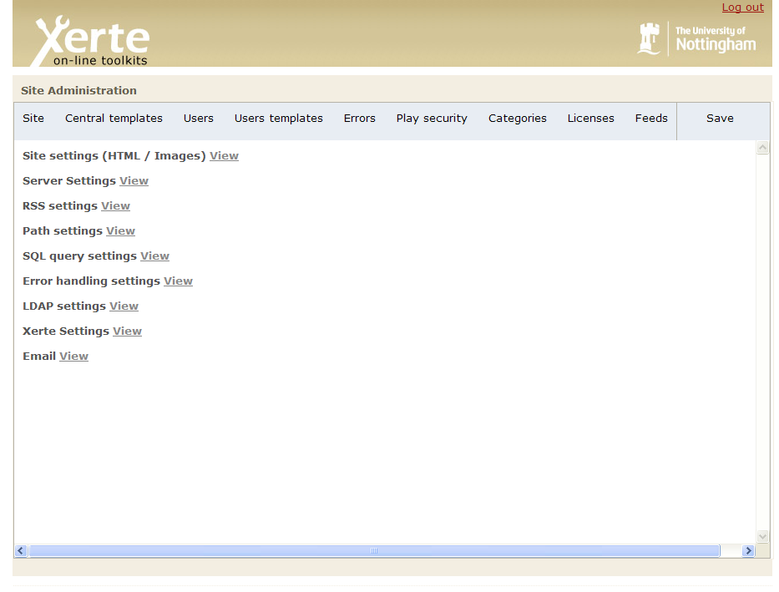

The main panel replicates the functionality of the installer. Here you can click on view, and then you will see the settings relevant to that area.

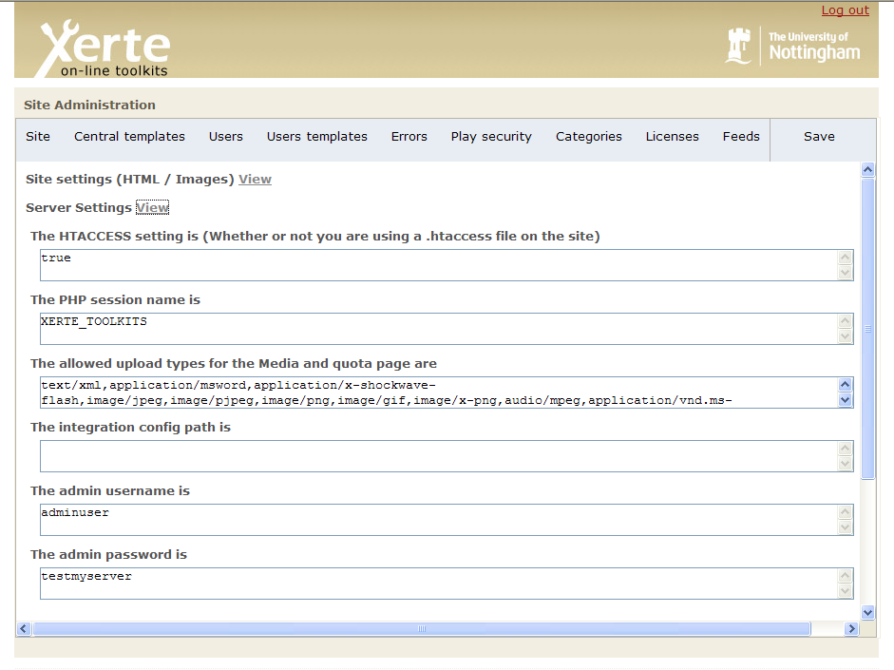

You can then change these and then click on “save” in the top right.

You can see a full list and explanation of what these values do earlier in this document.

#### Language support

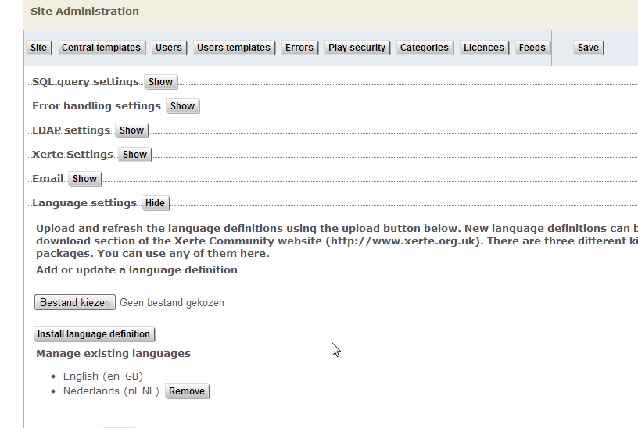

Part of the Site Administration Page also enables you to manage the installed language packs. Language Packs can be downloaded from the <http://www.xerte.org.uk> Community Website.

### Controlling What Templates Are Available: Central templates

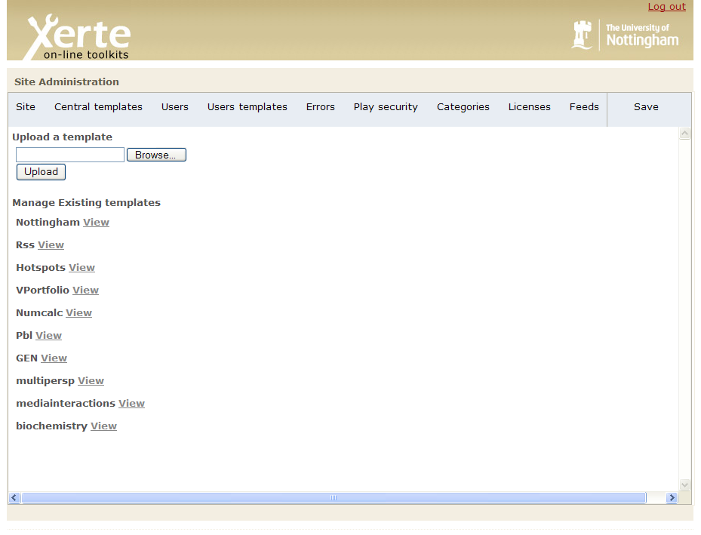

Clicking on central templates will bring up the following. Here you can see all of the templates currently installed on the site.

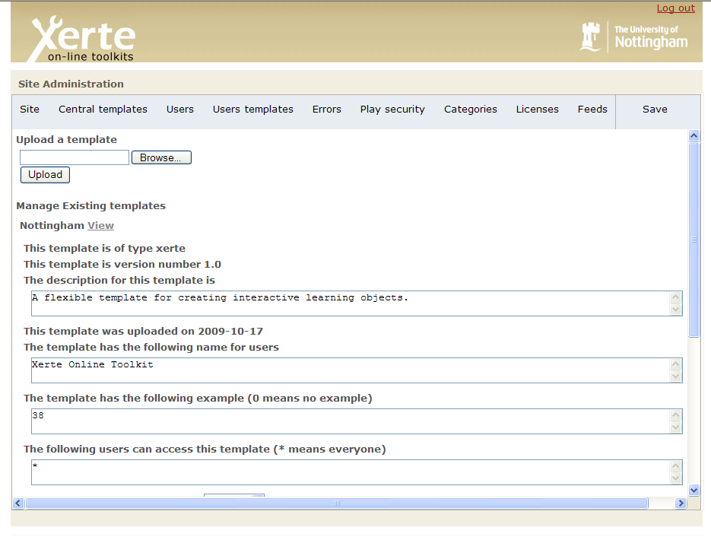

Clicking on view will bring up template details including

1)Module type for this template

2)Version number

3)Template description

4)Template name

5)Template example number

6)Template access restrictions (who can access this template)

7)Whether this template is active

These values can be changed and saved by clicking on upload – you can also use this feature to upload new templates, or replace an existing one (you cannot keep older versions backed up, this feature replaces them).

### Manager User Accounts: Users

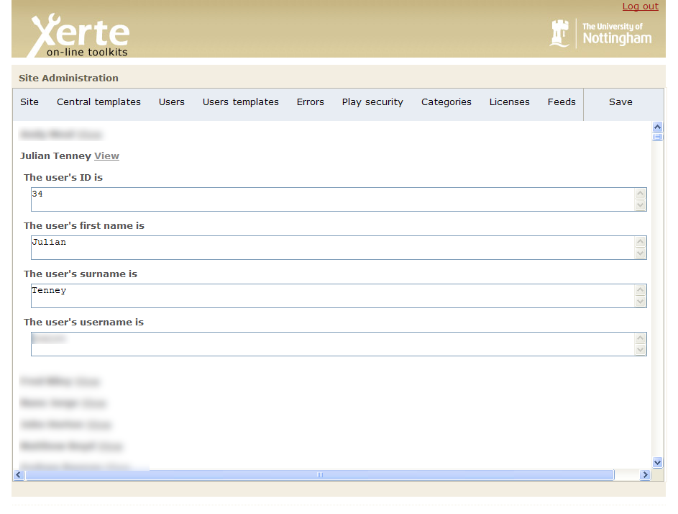

Clicking on users will bring up a list of user’s who have used the site. Clicking on view will bring up their details. You could use these tools for changing a users name or moving content from one user to another.

Also, if Db is chosen as the authentication method, you can manage your user accounts here.

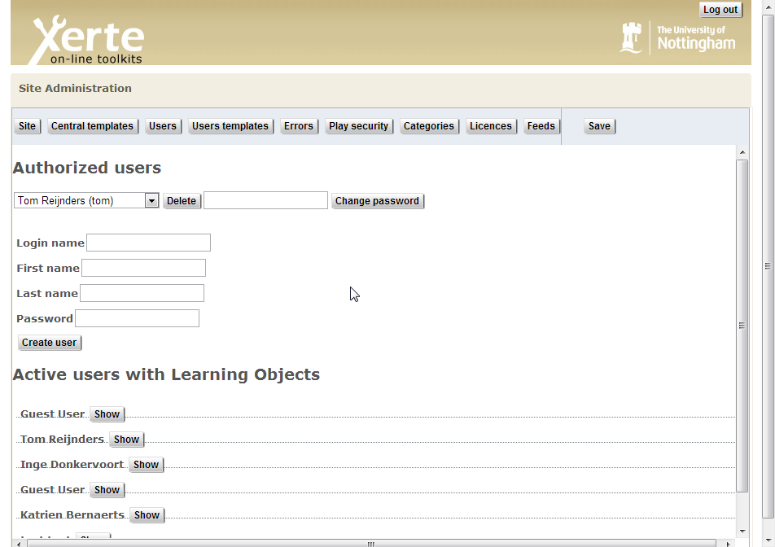

Note, this will ONLY be available to you when Db is chosen as authentication method.

### Managing User Projects: Users templates

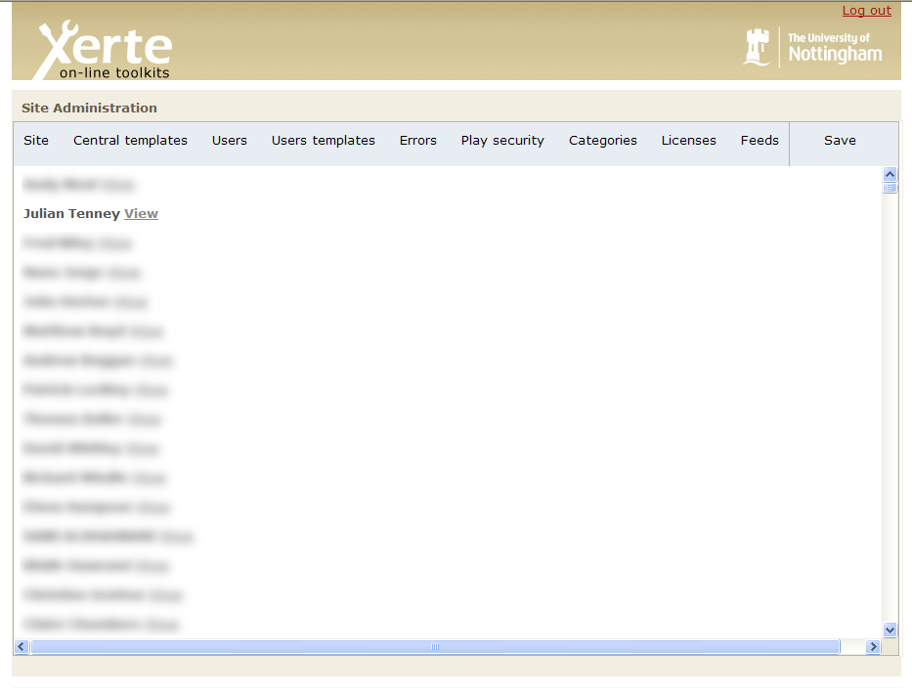

Clicking on user templates will bring up the following screen, and then you can click on view so you can see an individual users projects

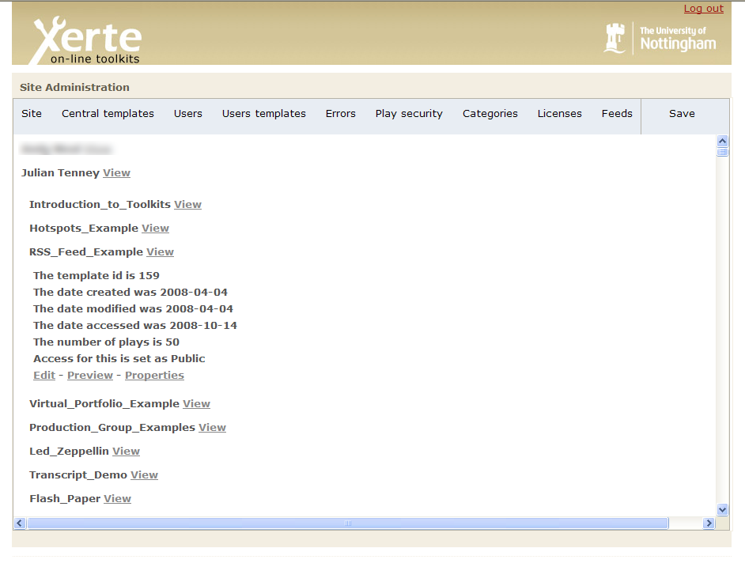

Then click on view to see that particular projects – details. Here you can (as adminiatrator) edit these templates and also look at properties.

### Tracing Site Activity: Errors

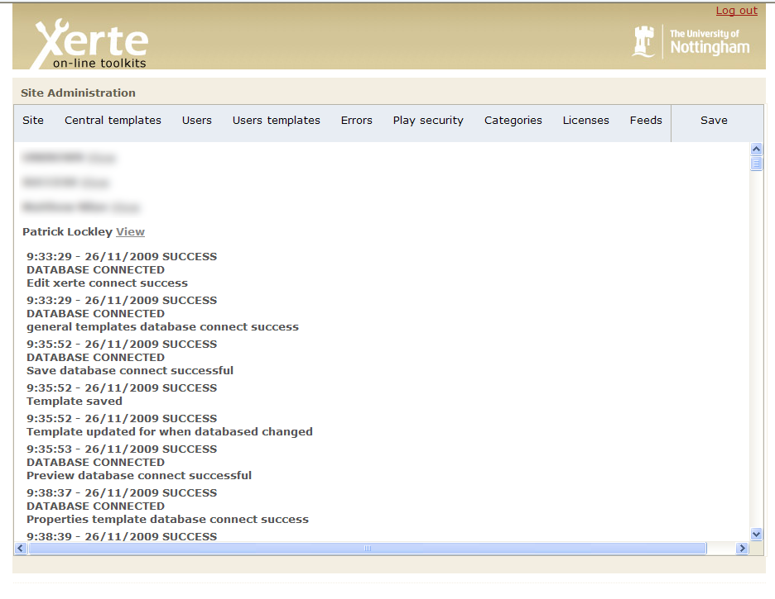

If you have turned error logs on, this screen will display the logs for each user. Click on view next to a user and you will see what the site has recently logged for them.

### Setting New Security Options: Play Security

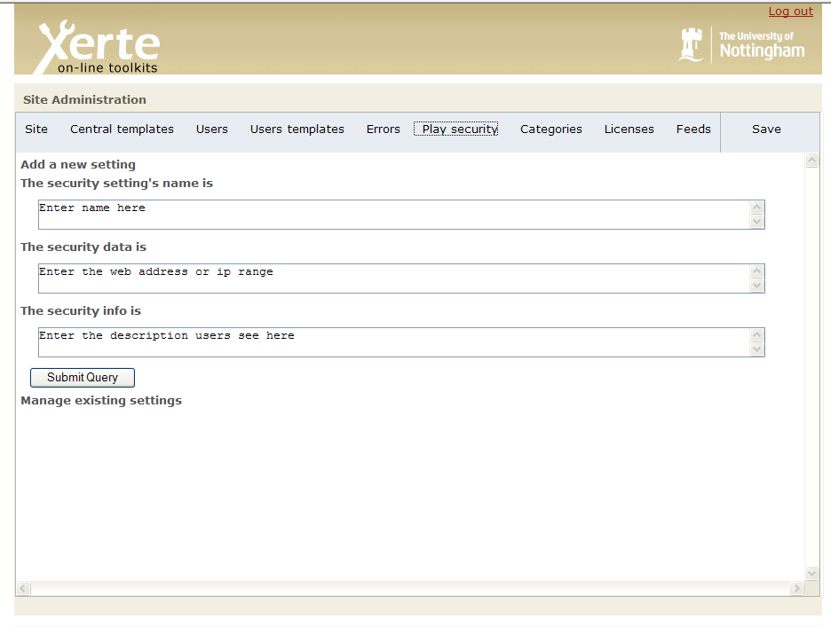

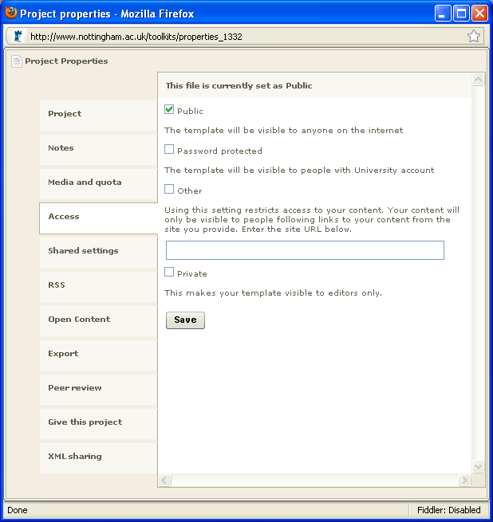

On the access tab in properties, you can see a list of possible access options. On this part on the management screen you can add new options.

The name is what is put next to the tick box, the data is either a colon separated list of web addresses (taken from server referrer) or ip addresses (taken from remote host) and the info is the small paragraph underneath the name.

**RSS options – “Categories”**

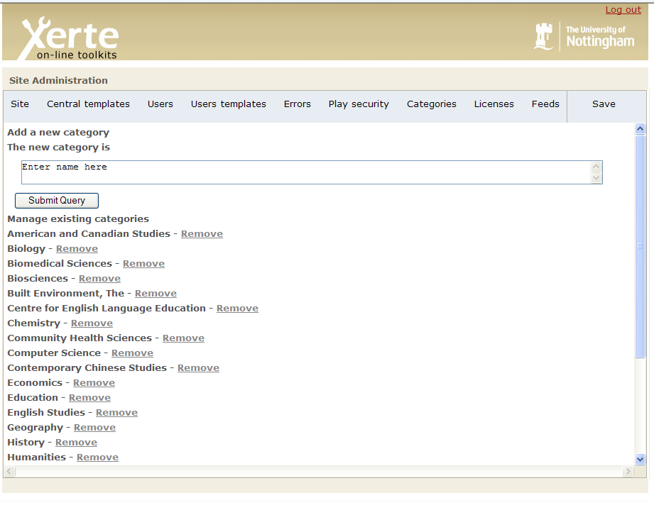

If you want to add or remove a new option for RSS categories, come to this page, and either type a new one in and click “submit query” or click on one you would like to remove.

### RSS Options: Licenses

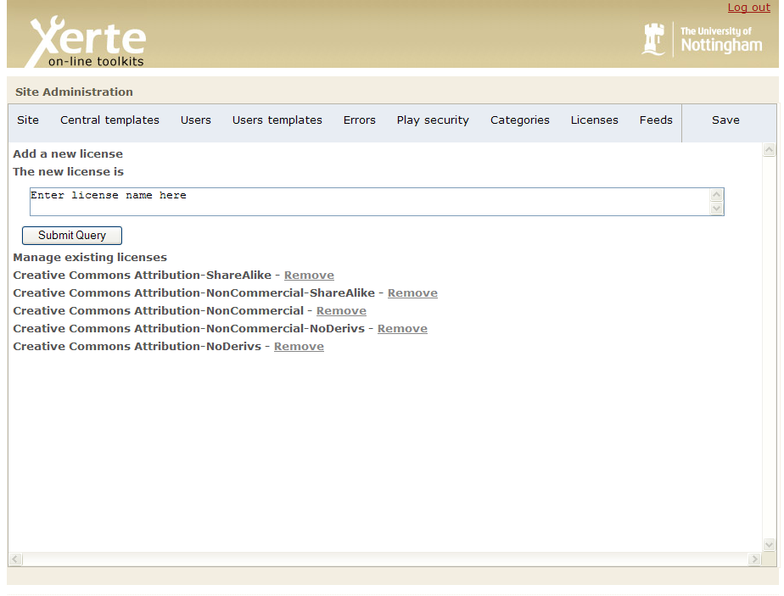

As well as categories, items submitted to an RSS feed should have rights for reuse attributed to them. This page allows you to add new or remove licenses you do not need.

### RSS Options: Feeds

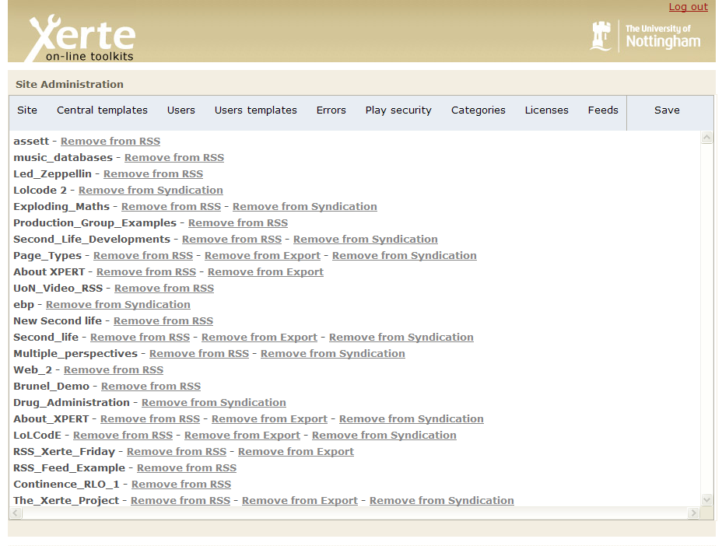

You may also find content in your feed which is not suitable. This page allows you to remove items from the three feeds (RSS, Export and Syndication) that Xerte Online Toolkits supports.